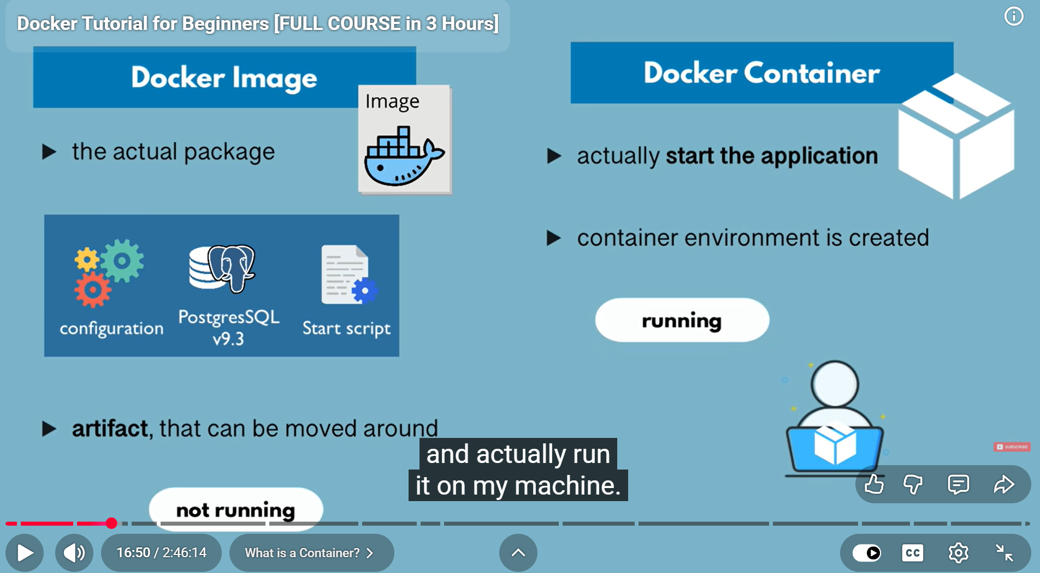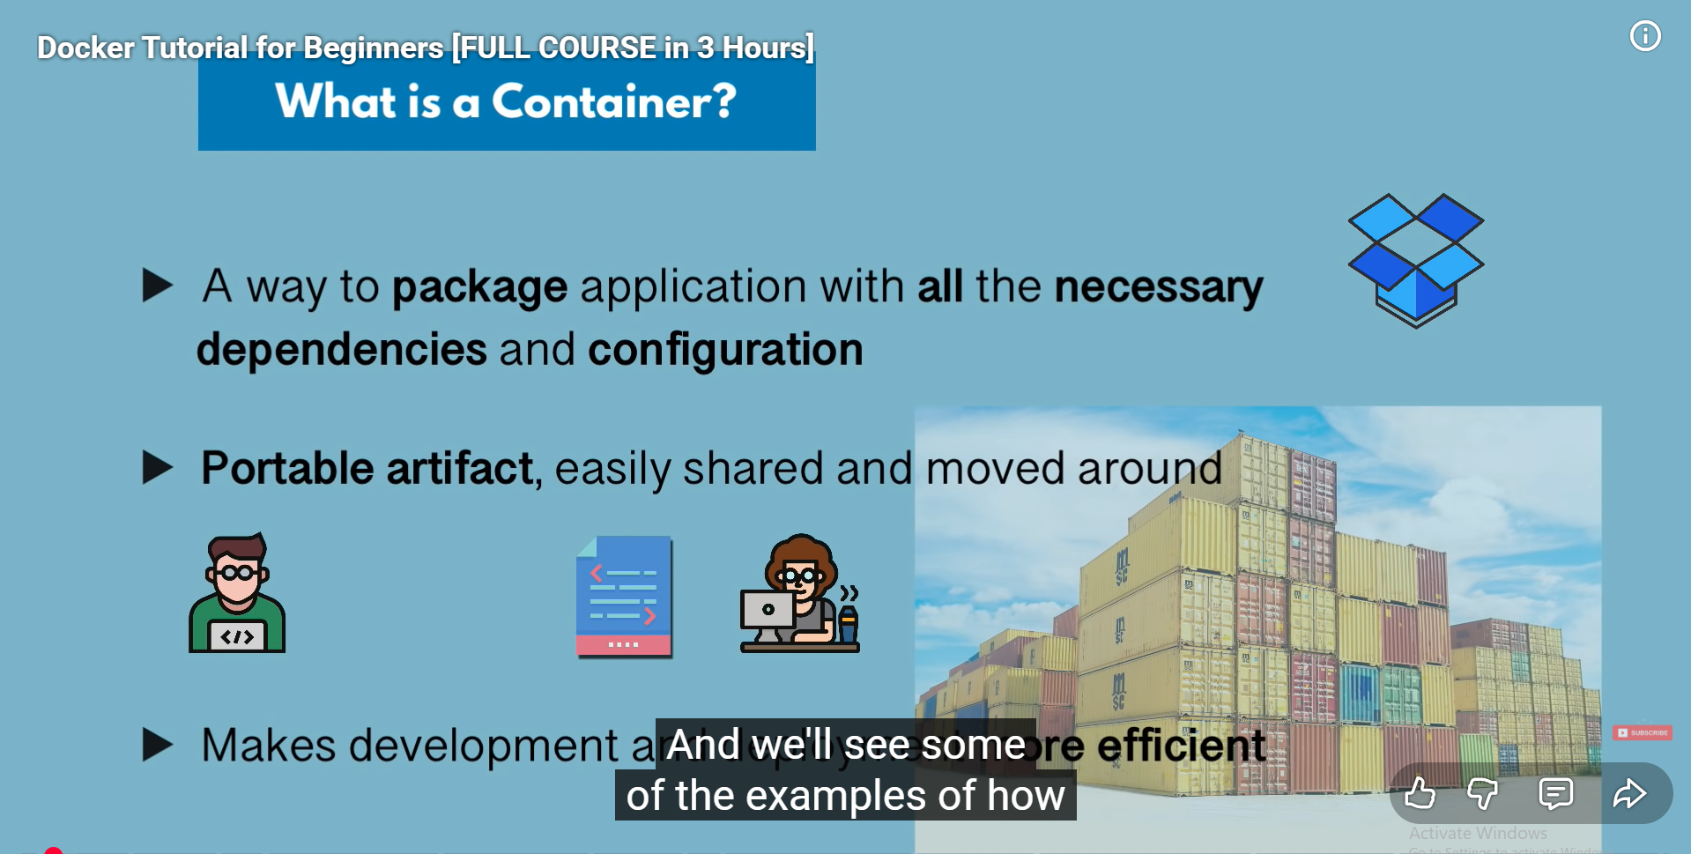

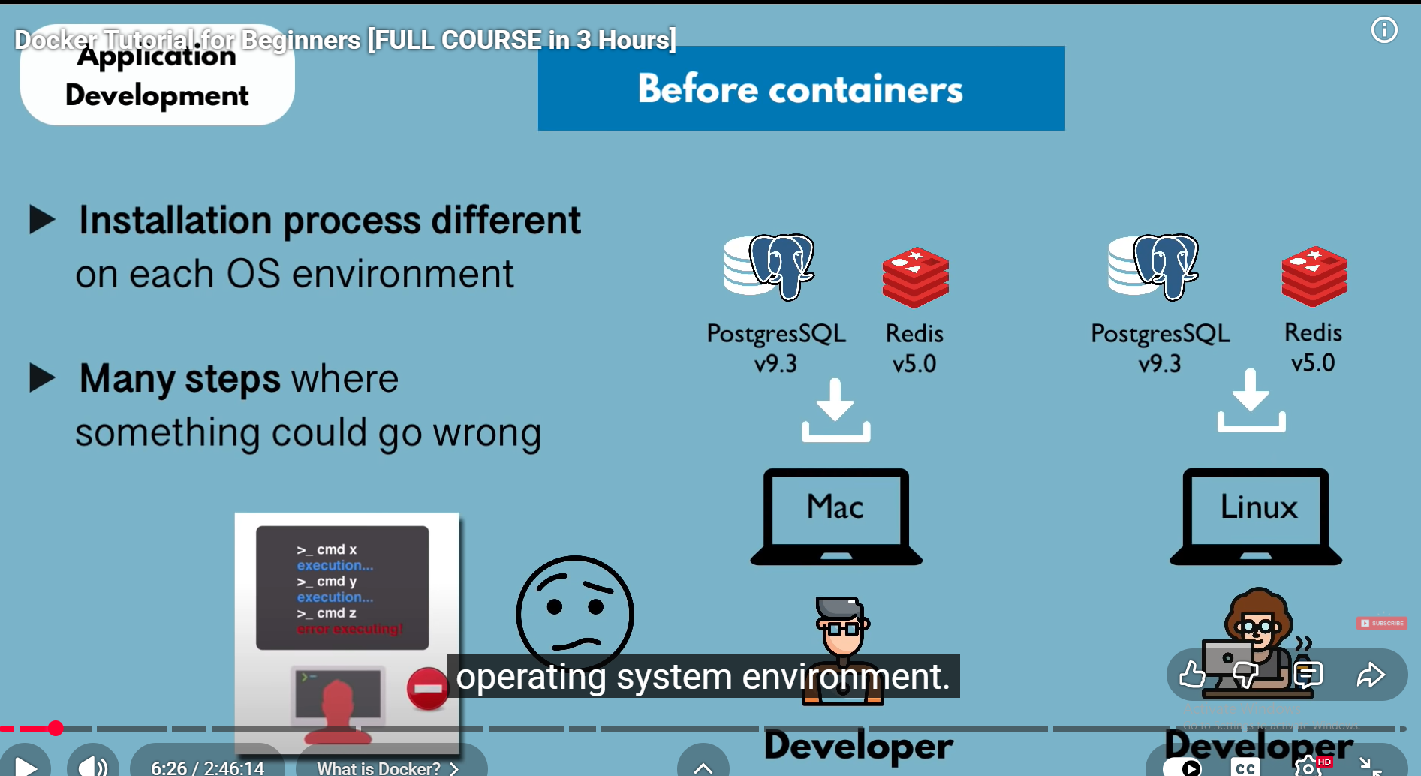

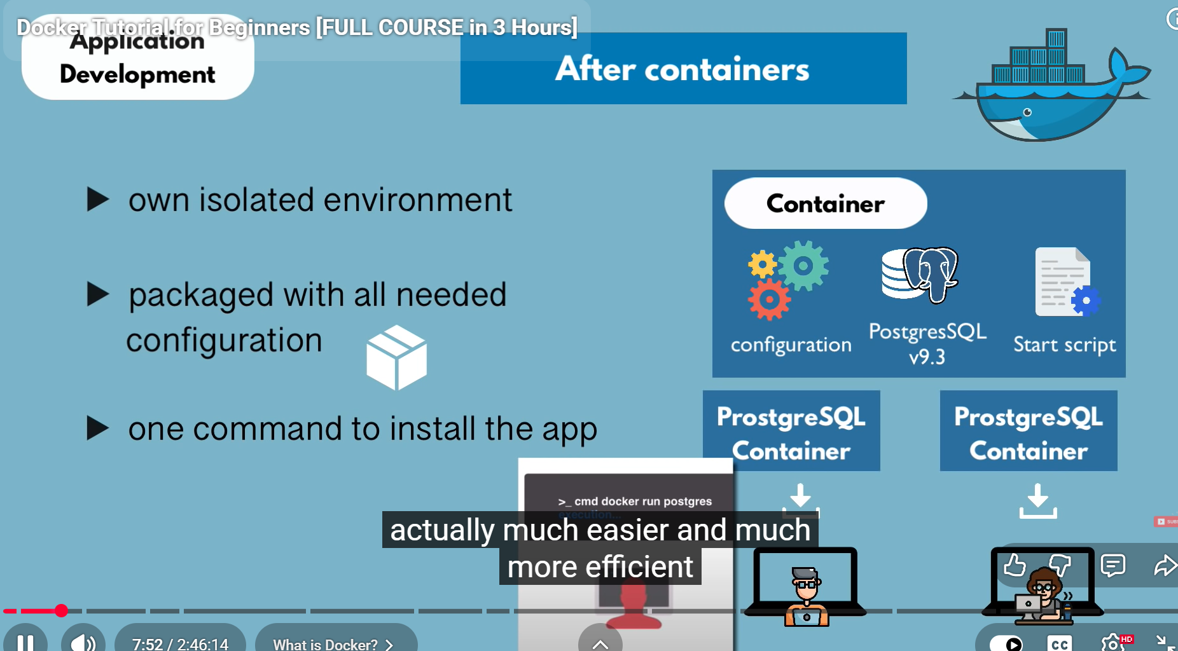

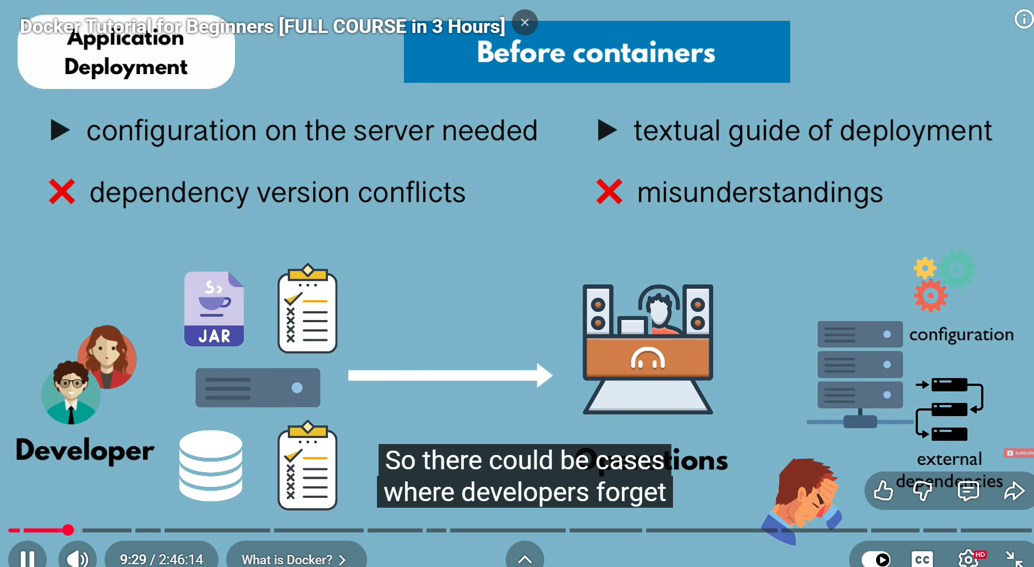

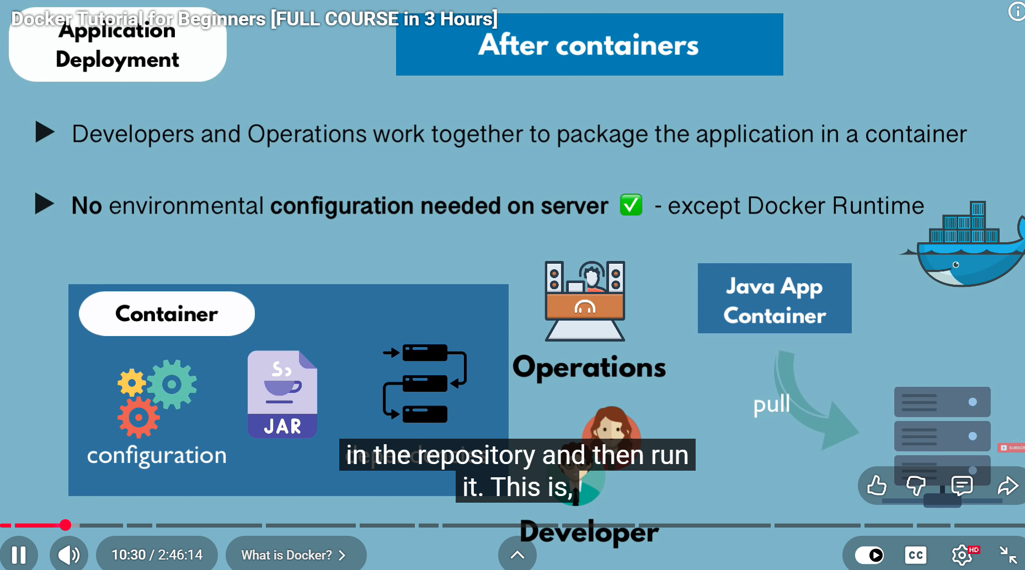

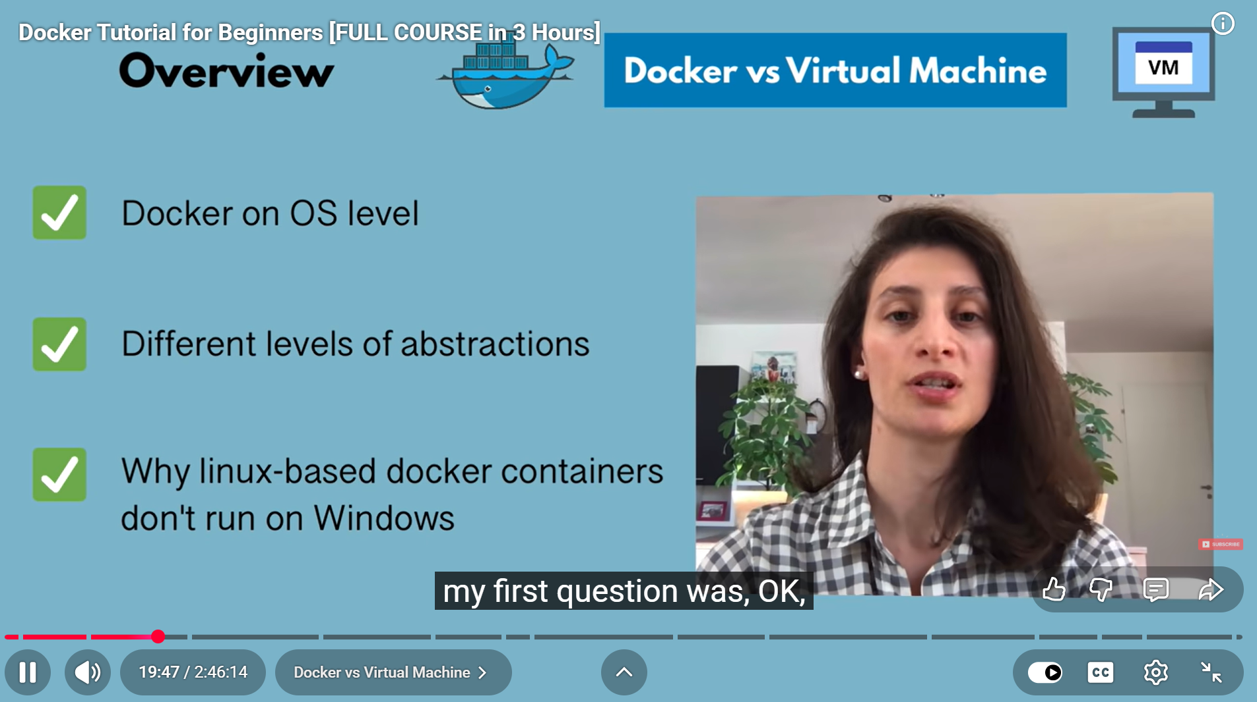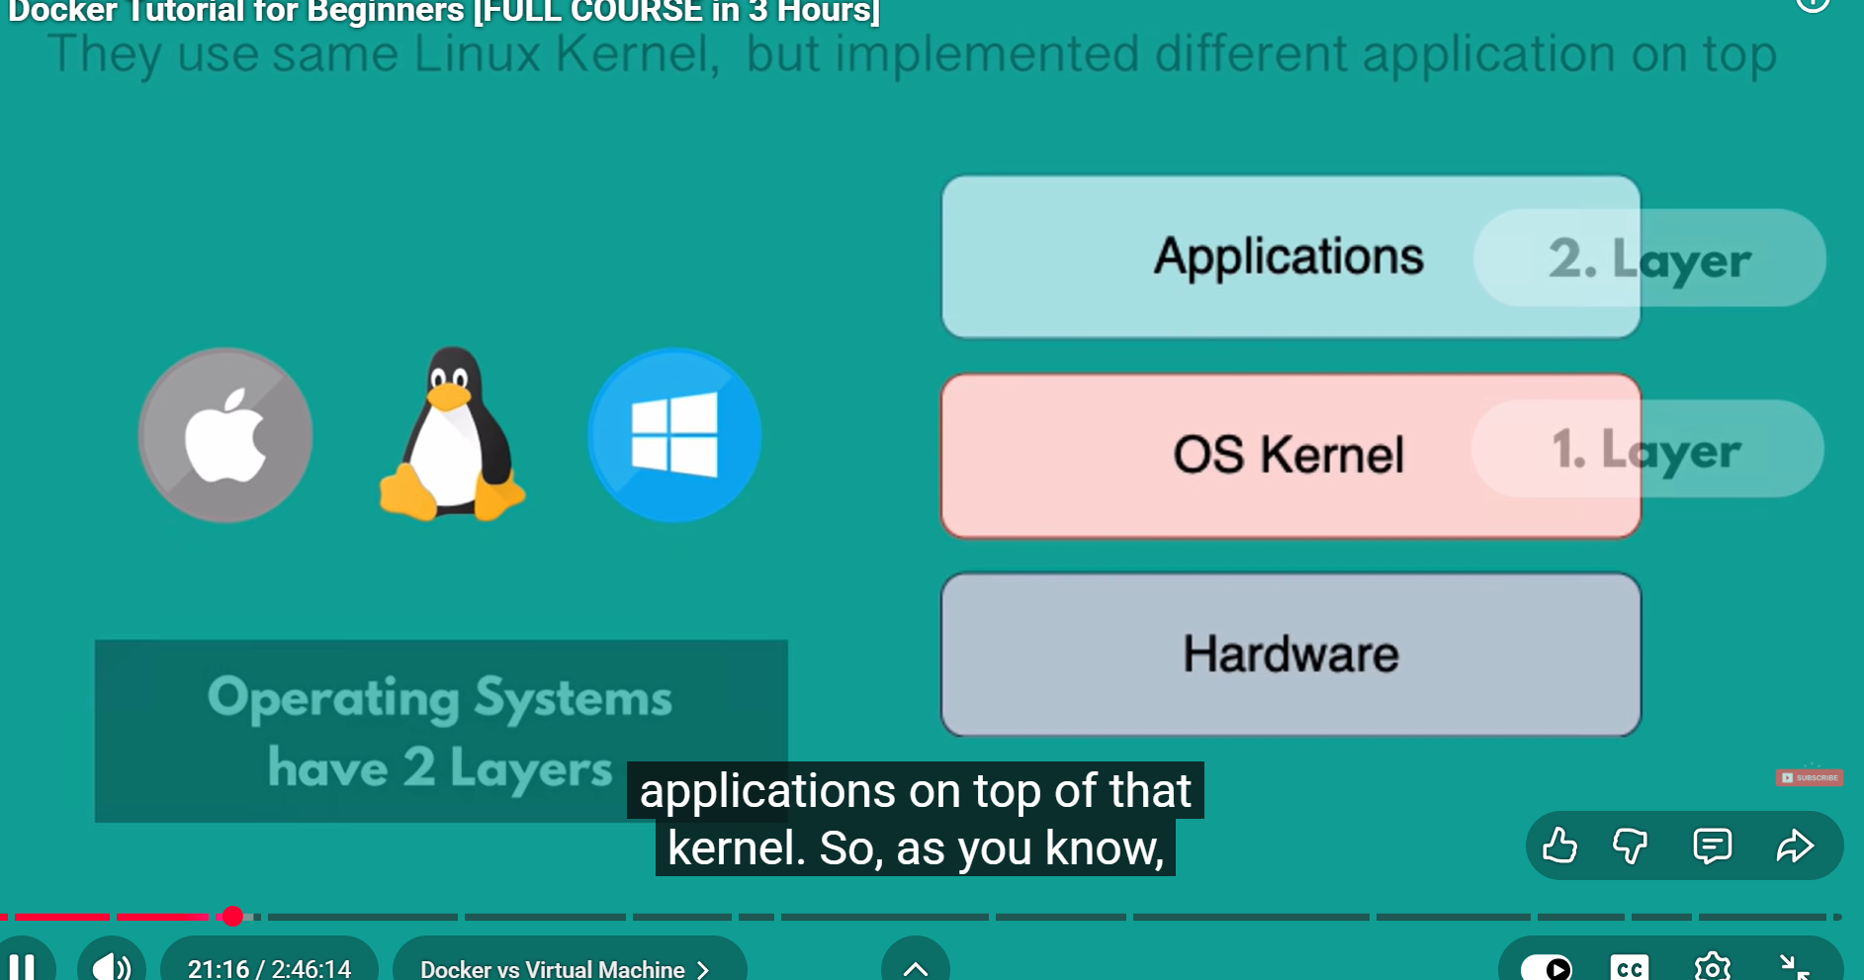

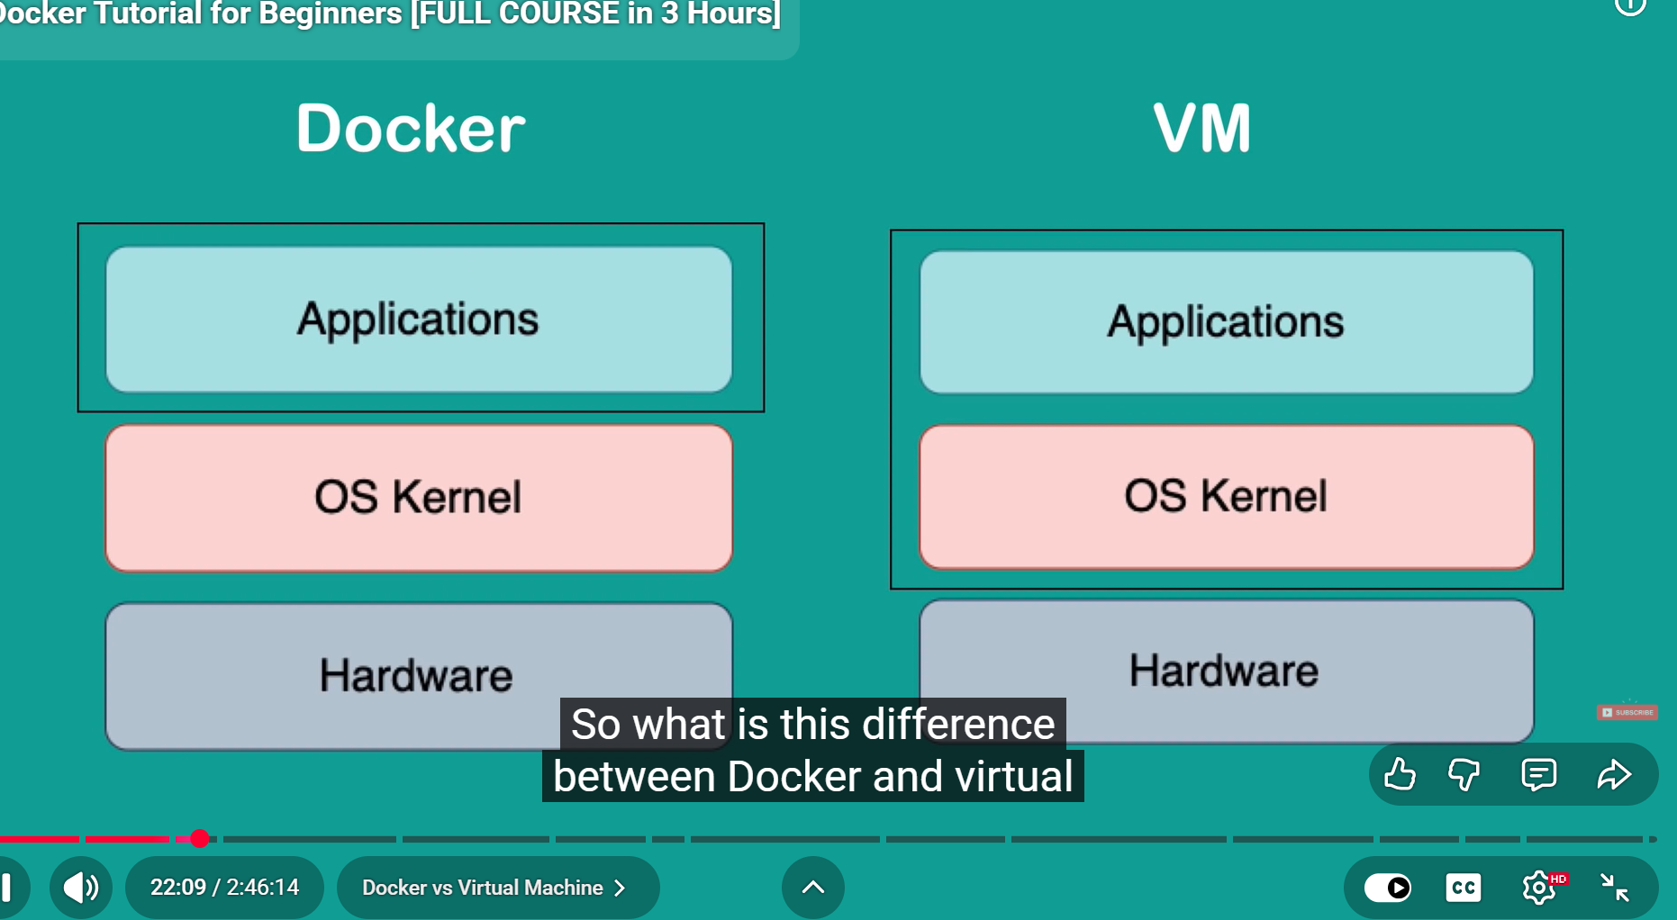

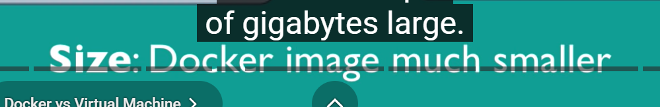



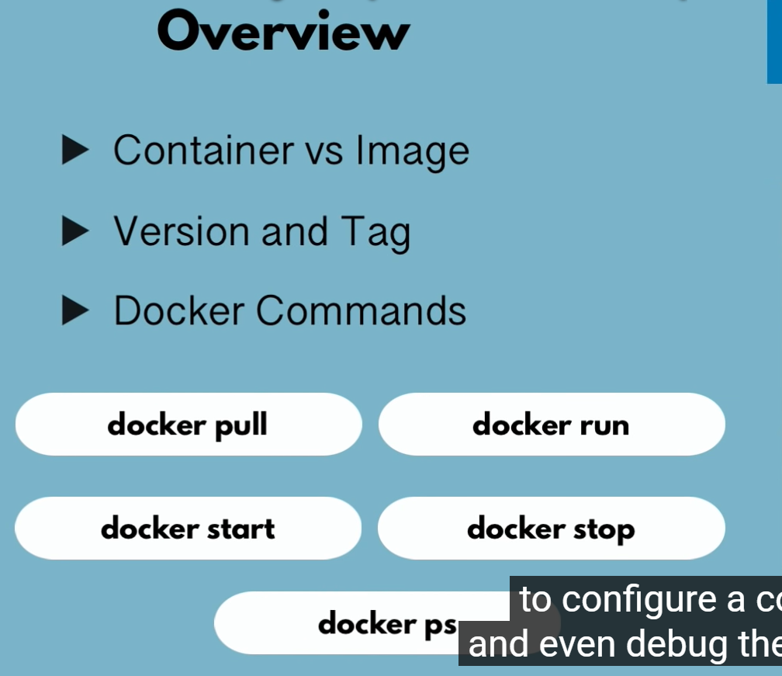



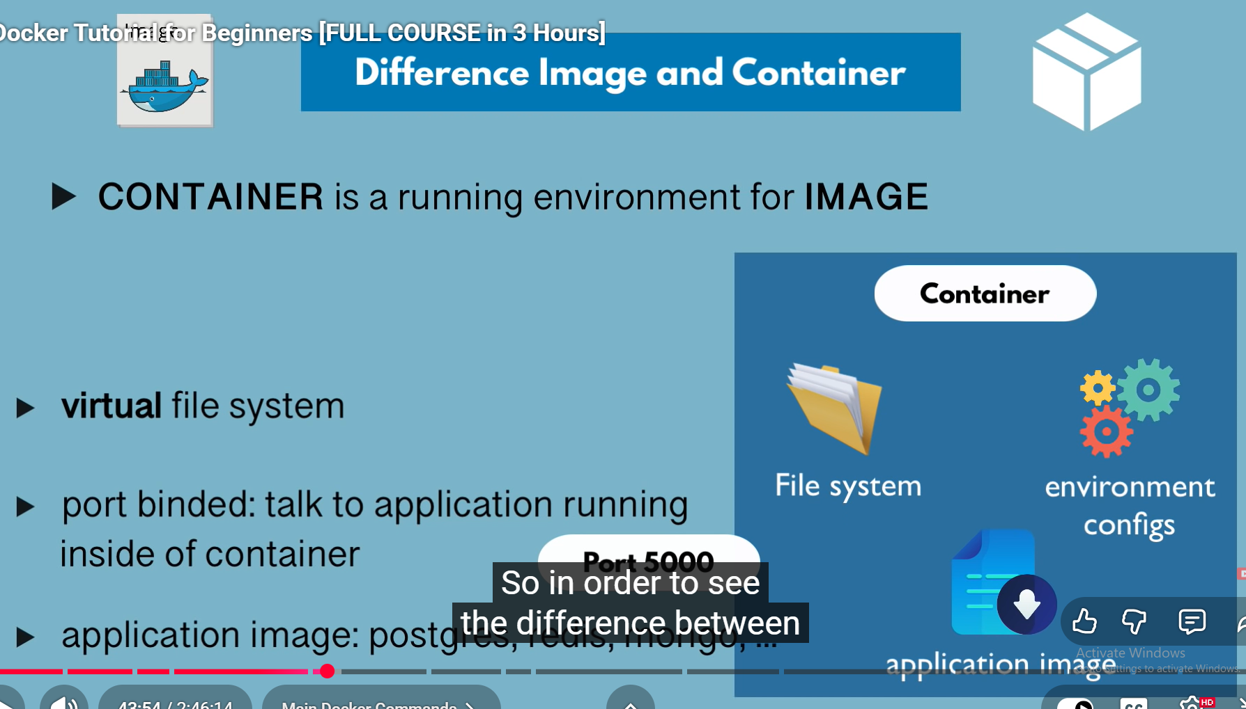

Commands: -
- Docker ps = use to show list running containers
- Docker images = user to show list of images
- Docker pull = use to pull docker images
- Docker run = use to run the imges (eg. Docker run redis)
- Docker run -d redis (for detached mode)
The docker run -d command starts a Docker container in detached mode, meaning it runs in the background without attaching to the current terminal session.
Key effect: The terminal is not hijacked by the container’s output, allowing you to continue using the command line.
Output: Docker returns the container’s unique ID immediately, instead of showing the container’s logs.
Use case: Ideal for long-running services (like web servers, databases) that should operate continuously in the background.
Management: To view running containers, use docker ps. To stop a detached container, use docker stop <container_id>.
Note: If the container exits immediately (e.g., runs a one-time task), docker ps won’t show it—use docker ps -a to see stopped containers.
Example:
docker run -d nginx starts an Nginx web server in the background.
Output: a1b2c3d4e5f6 (the container ID).
- Docker stop (container id) (to stop the container)
- Docker start (container id) (to start the container)
- Docker ps -a ((all containers) - this will show all the containers that are running as well as that are not running).
- docker run image_name:image_version (docker run redis:4.0) (this will pull the image and start the container)
- docker exec -it 10d821acbcf8 /bin/bash (take you inside the container)
then ls
then cd / or cd /home go inside the directories
virtual file system in which you can navigate throughout the directories

Demo project overview

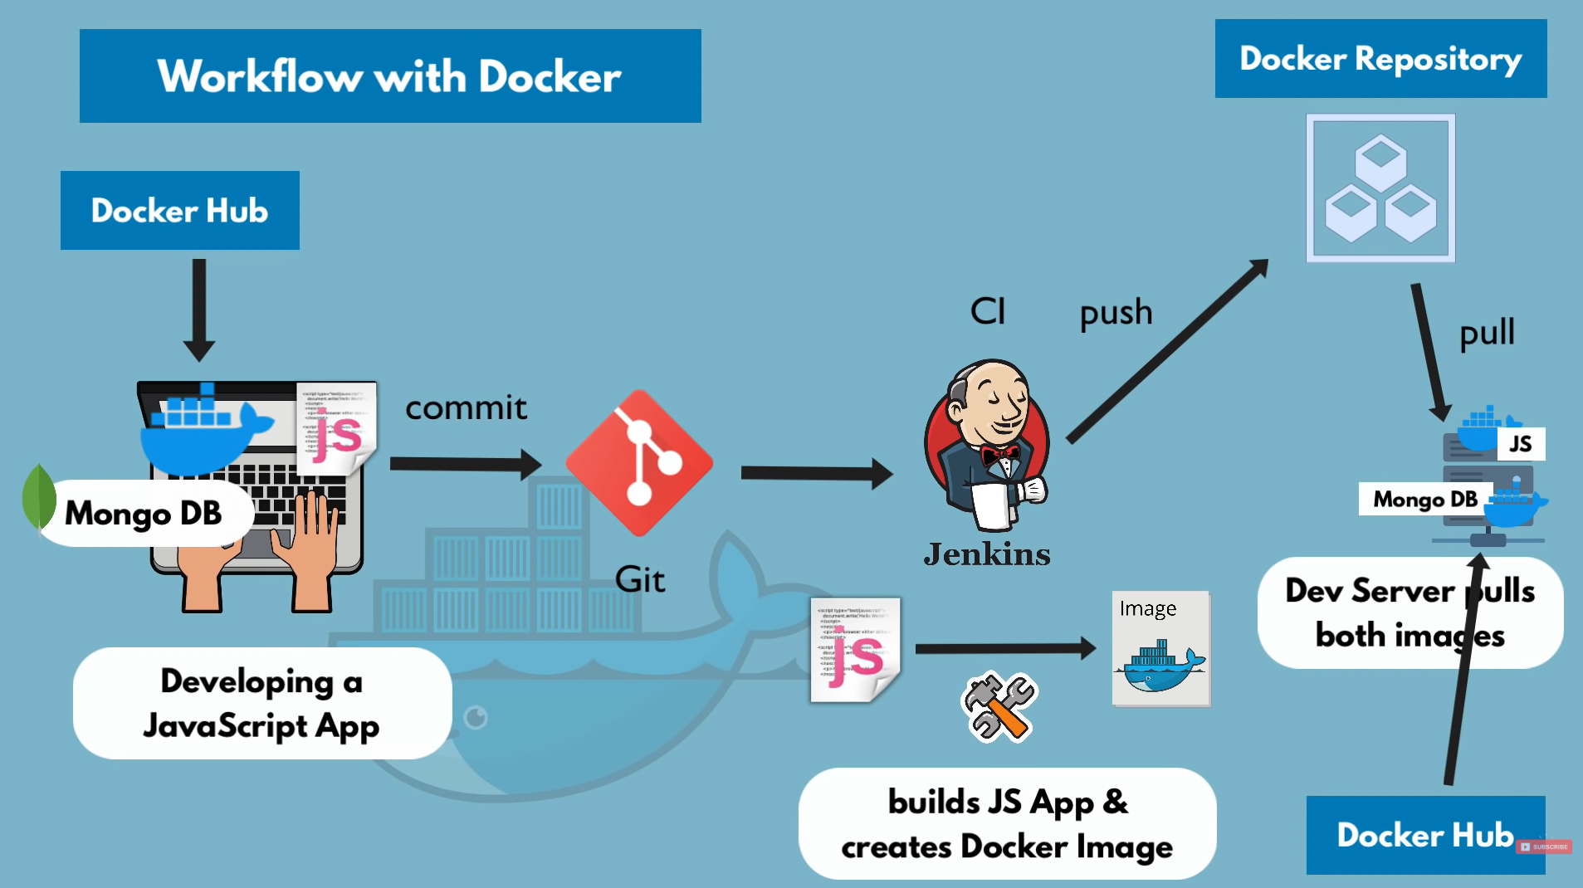

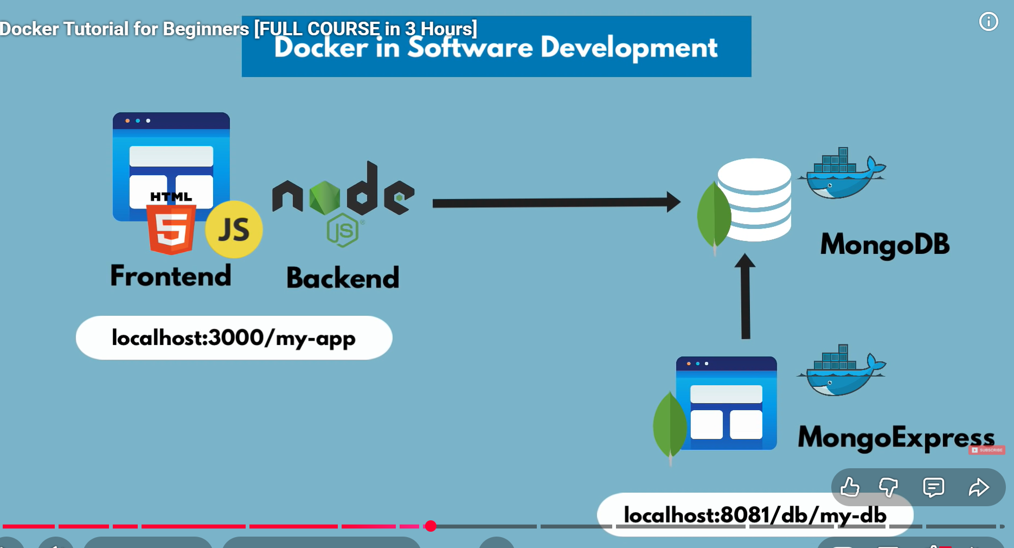
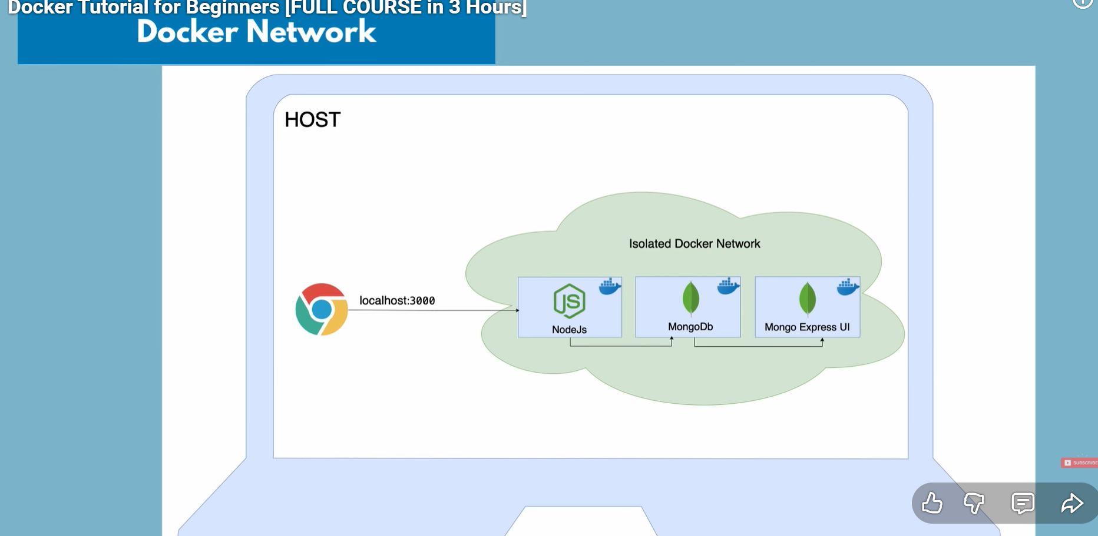

Docker compose -
Docker Compose uses a variety of commands to manage the lifecycle of multi-container applications defined in a single
compose.yaml (or docker-compose.yaml) file.
Here are the most commonly used docker compose commands:
- docker compose up: Creates and starts containers, networks, and volumes for all services defined in the Compose file.
  - Use the -d (detached) flag to run containers in the background.
  - Use the --build flag to force a rebuild of images before starting containers, useful after making changes to a Dockerfile or source code.
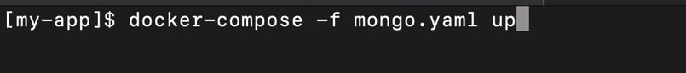
- docker compose down: Stops and removes containers, networks, and all resources created by up.
  - Use the --volumes flag to also remove named volumes, which are preserved by default.
- docker compose ps: Lists the running containers within the current project, showing their status, ports, and names.
- docker compose logs: Views the consolidated log output from all services. You can also specify a service name to view logs for only that service.
- docker compose build: Builds or rebuilds the service images defined in the Compose file without starting the containers.
- docker compose pull: Pulls the latest versions of the base Docker images specified in your configuration from their registries.
- docker compose exec: Runs an arbitrary command inside a running service container, useful for debugging or maintenance (e.g., docker compose exec web bash to open a shell).
- docker compose run: Runs a one-off command in a new container based on a service's configuration. This is ideal for tasks like database migrations or testing.
- docker compose stop: Stops running containers without removing them, so they can be started again quickly with docker compose start.
- docker compose restart: Restarts all service containers.
- docker compose config: Validates and prints the effective configuration, which helps in debugging syntax or merge issues when using multiple Compose files.
- docker compose version: Shows the installed Docker Compose version information.

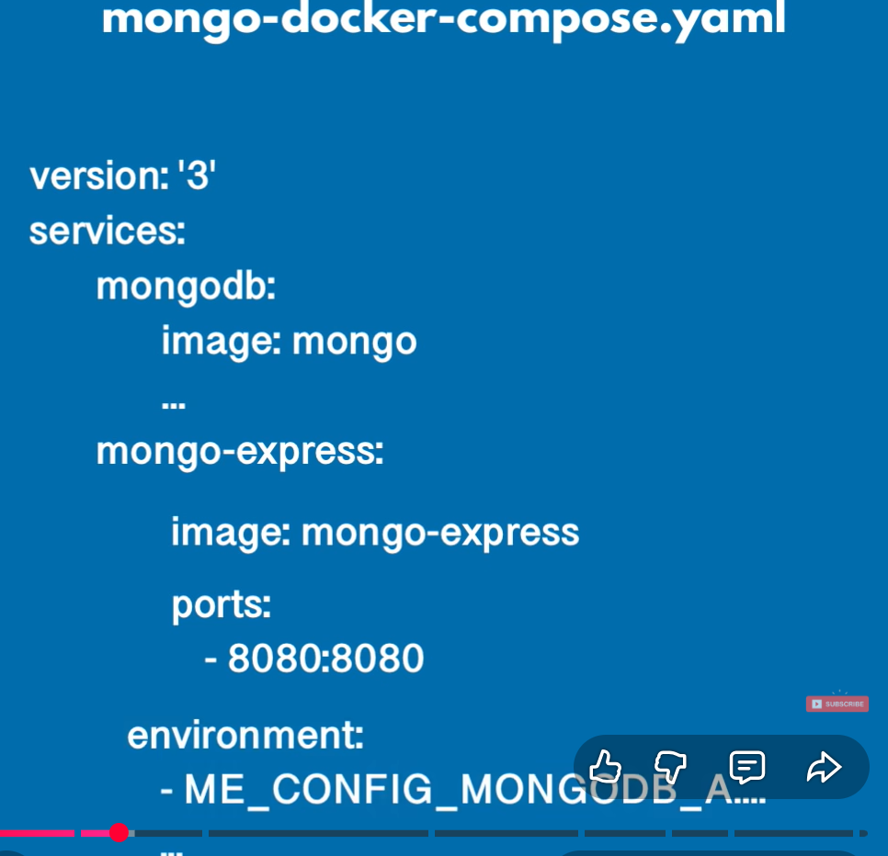

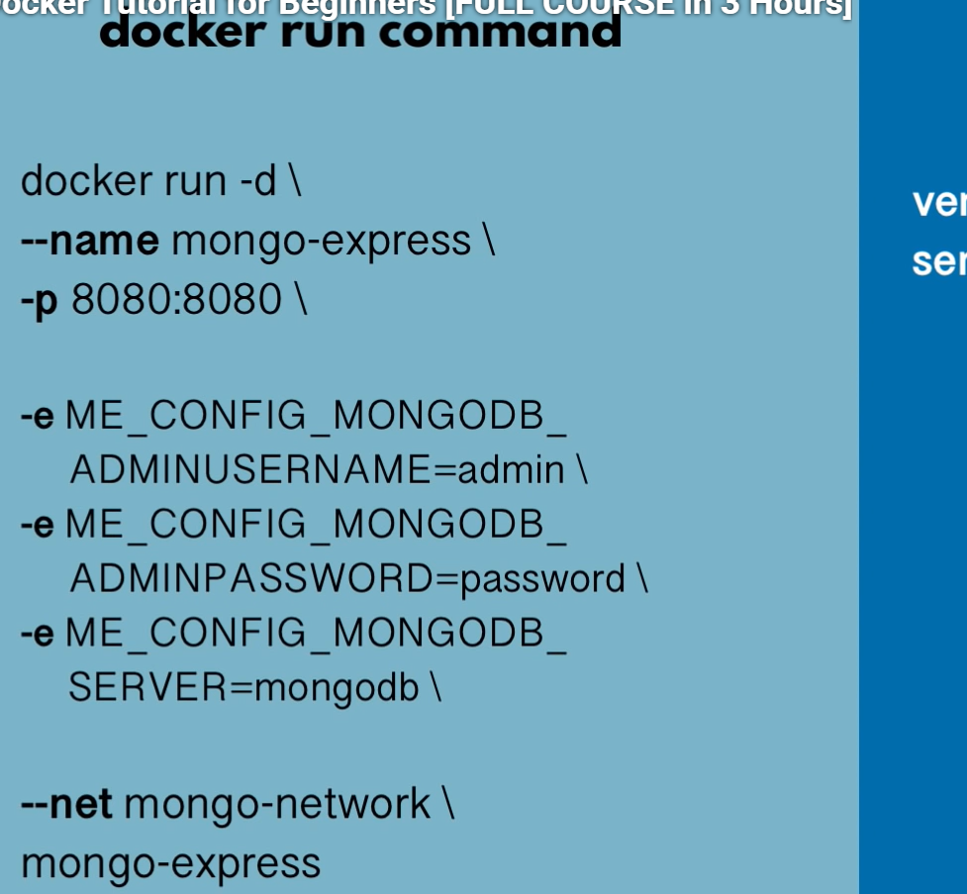
Creating the docker compose file
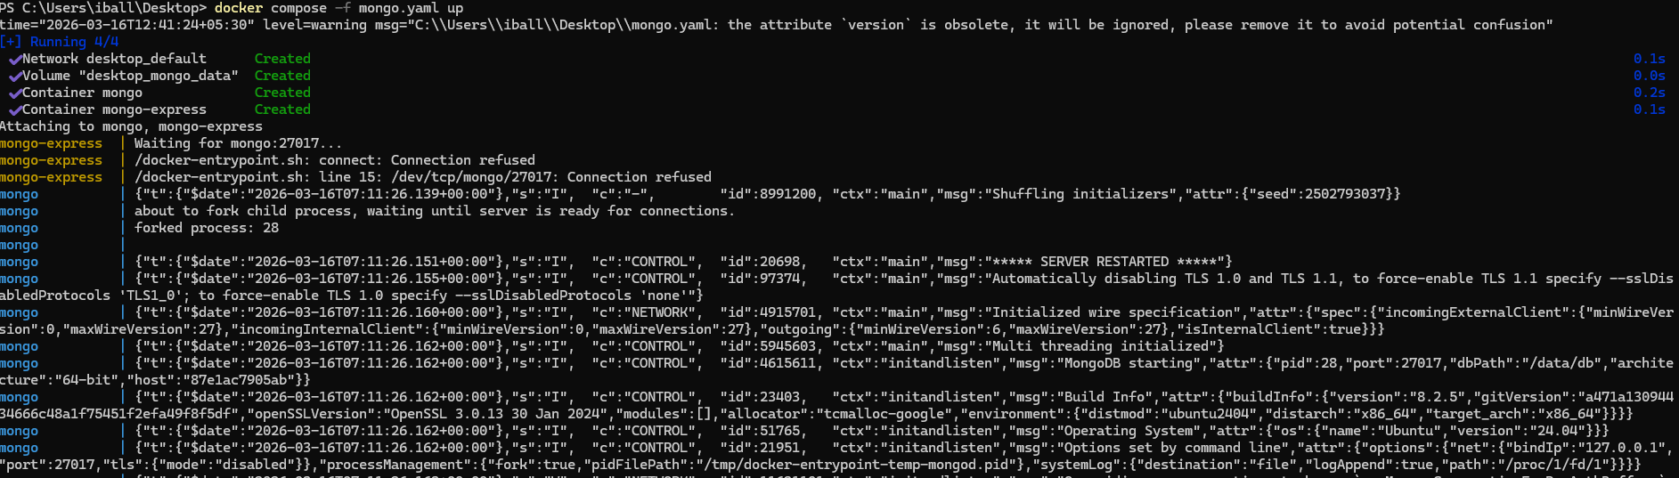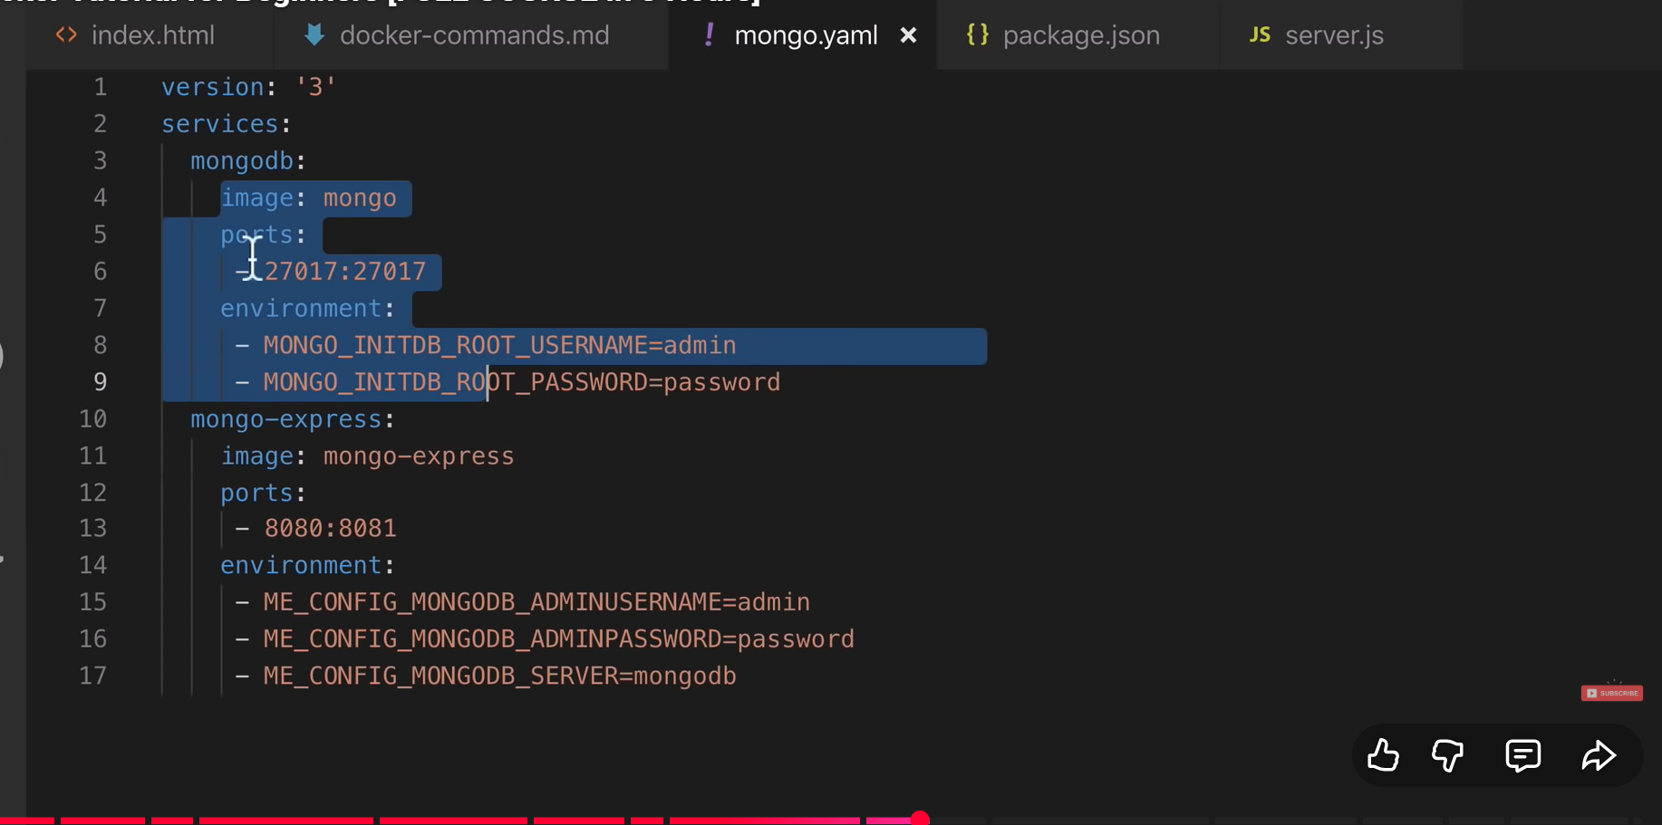

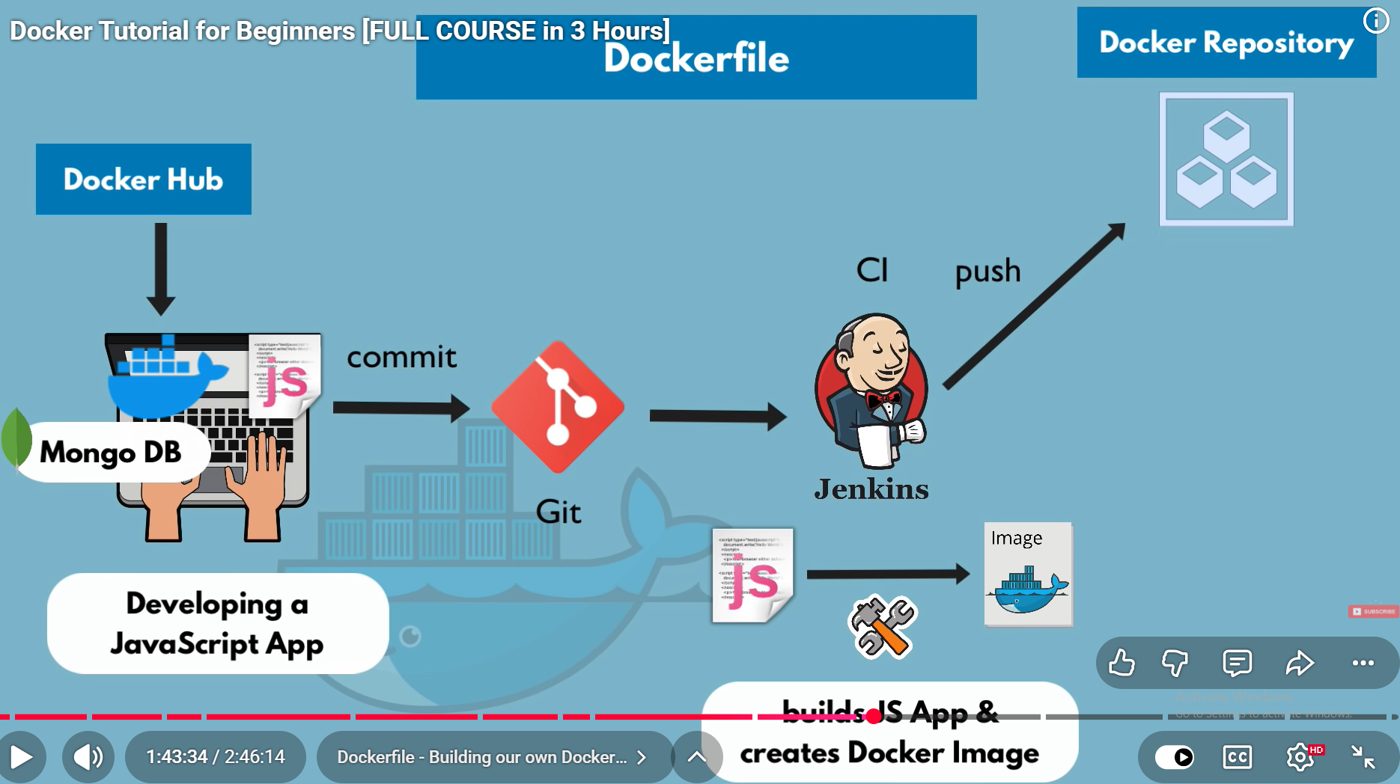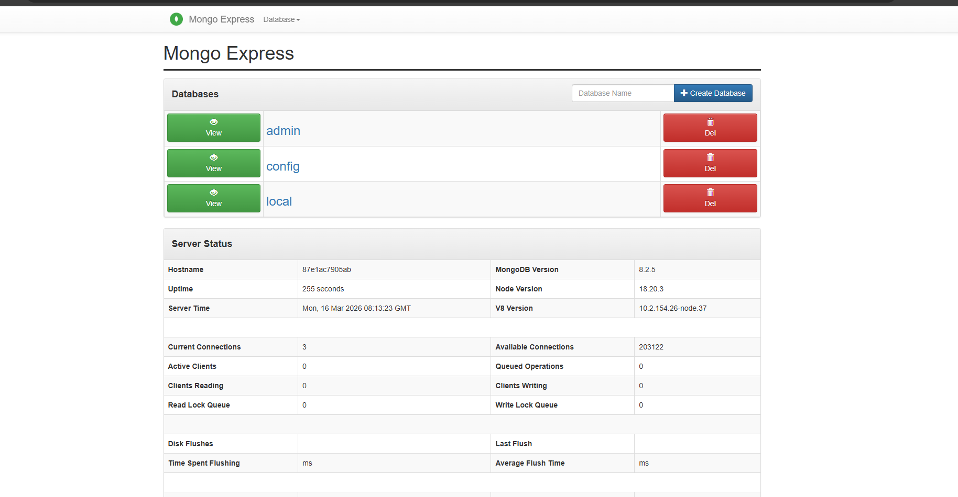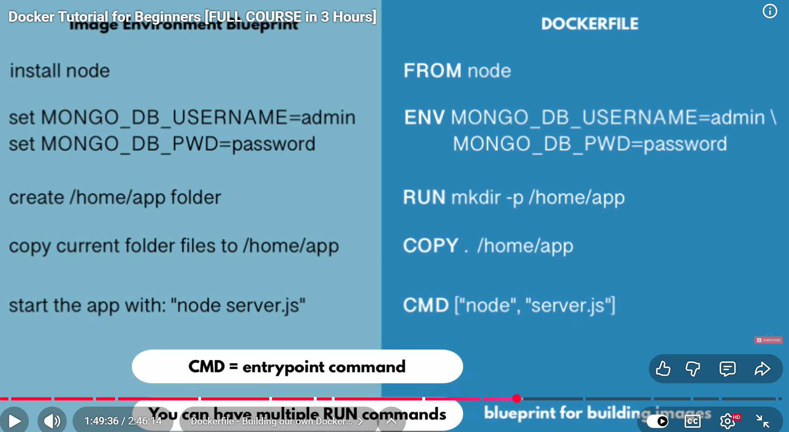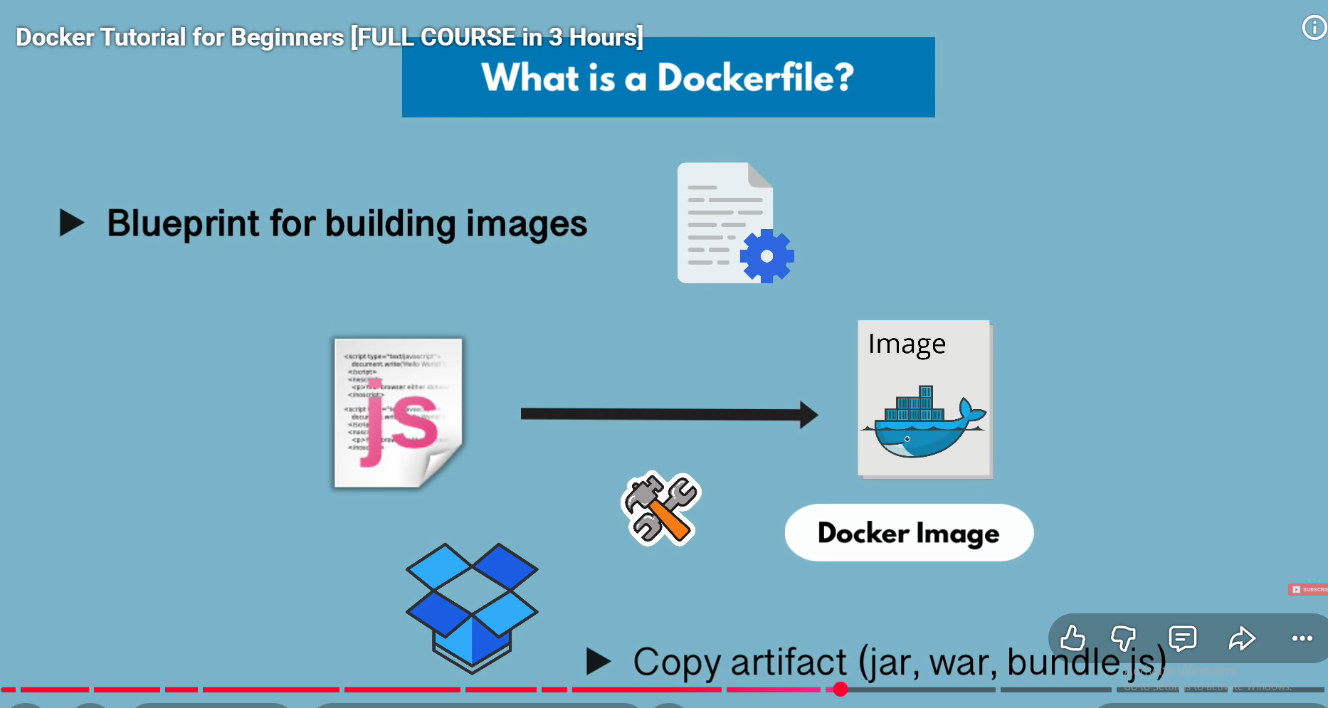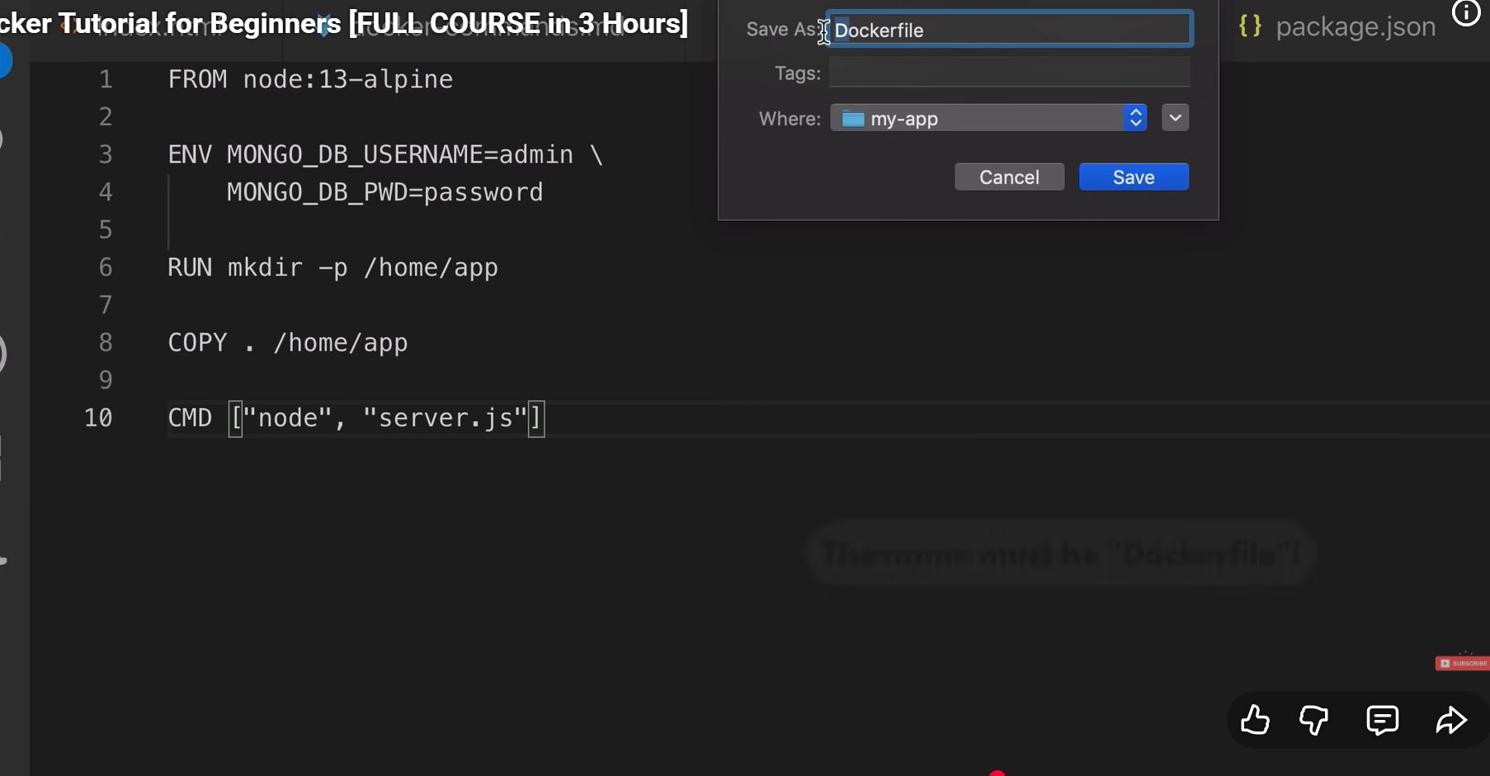

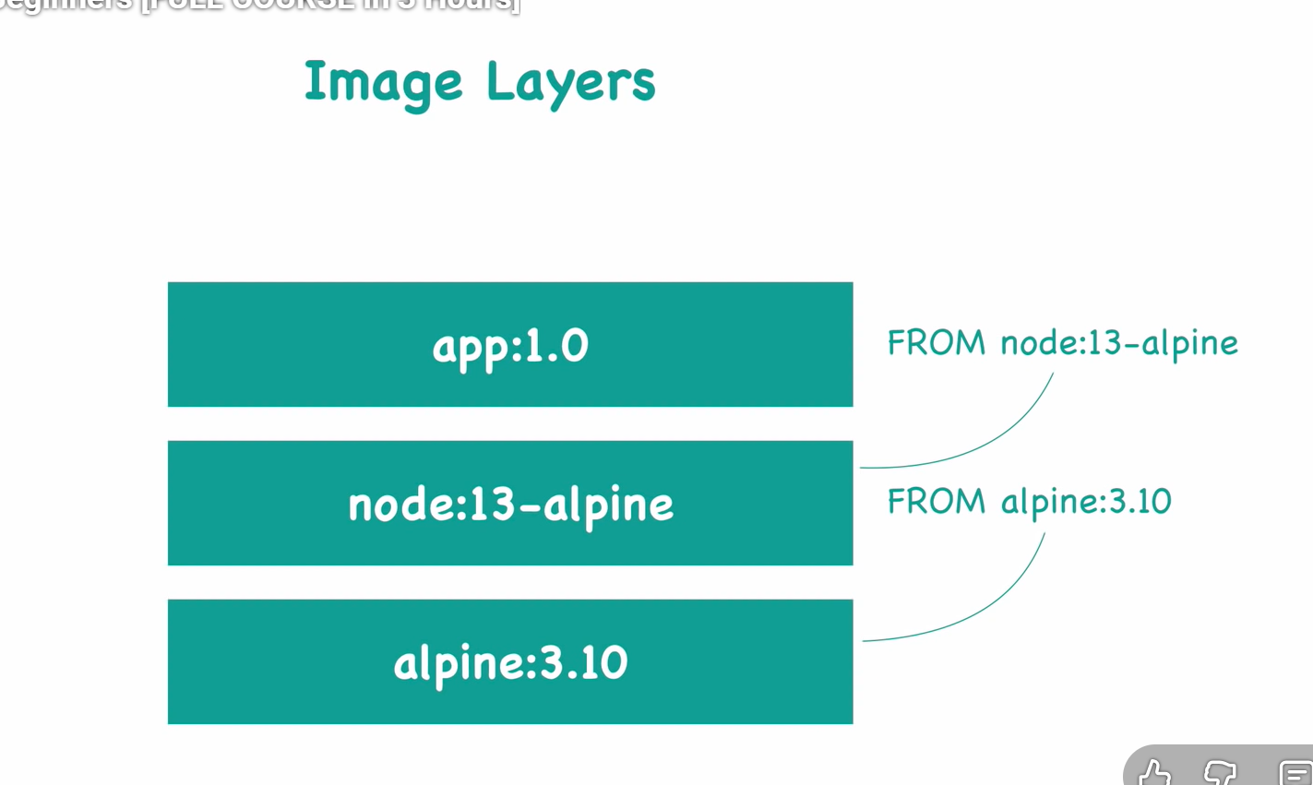
building a image

Run docker build -t my-app:1.0
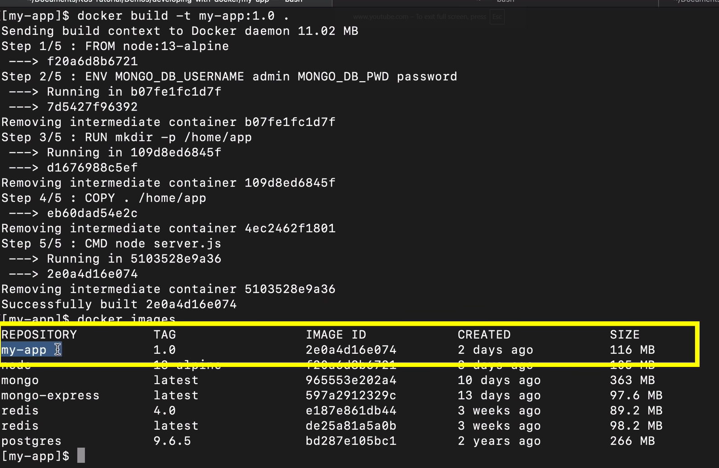

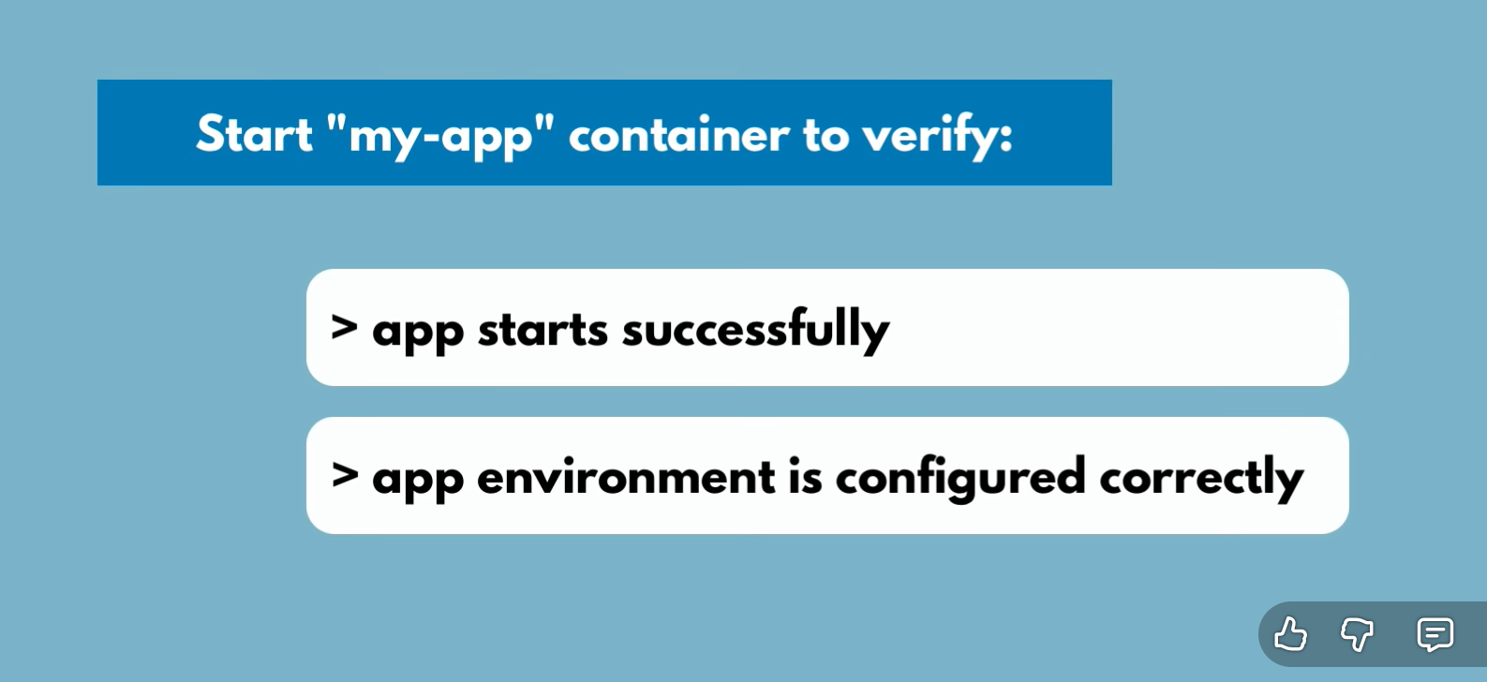
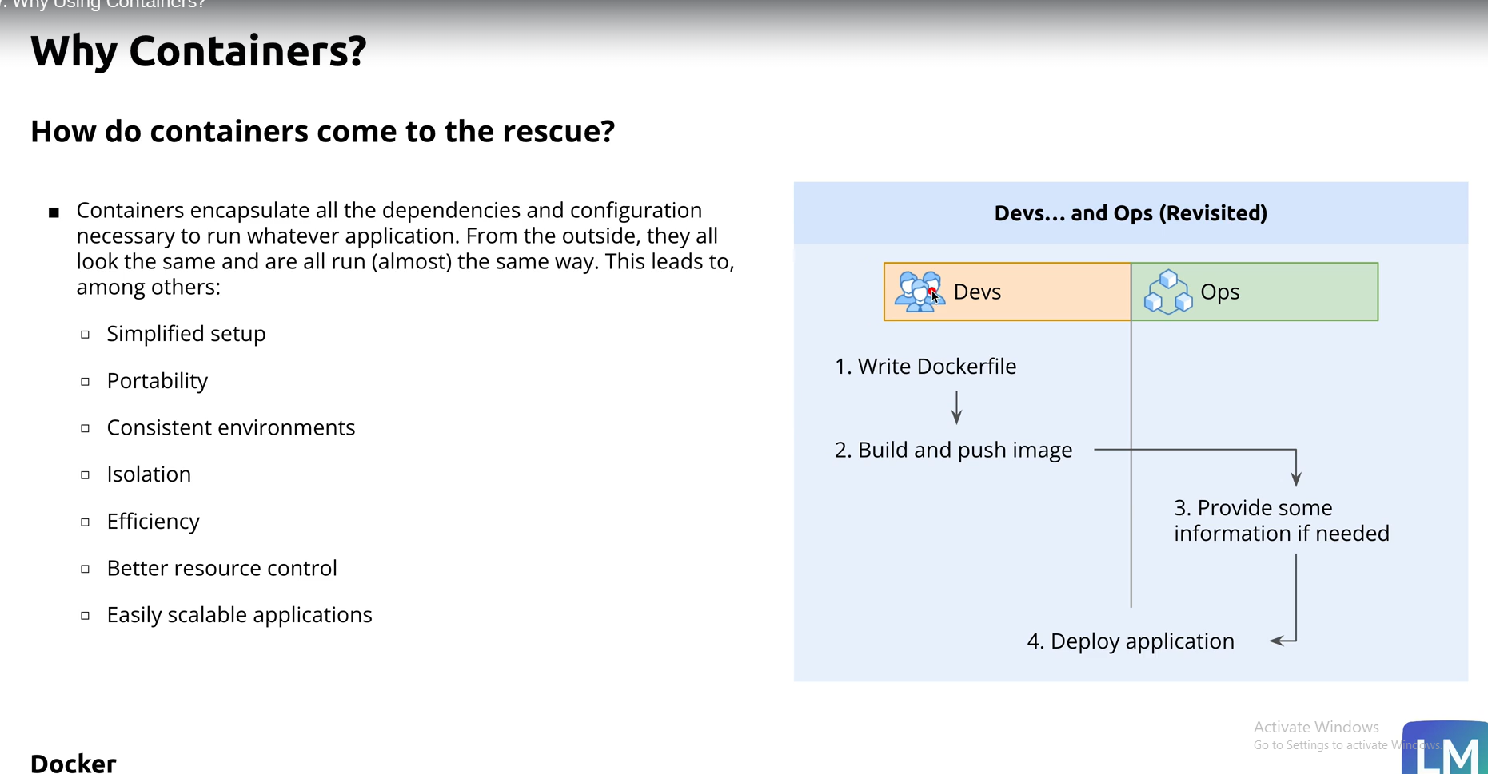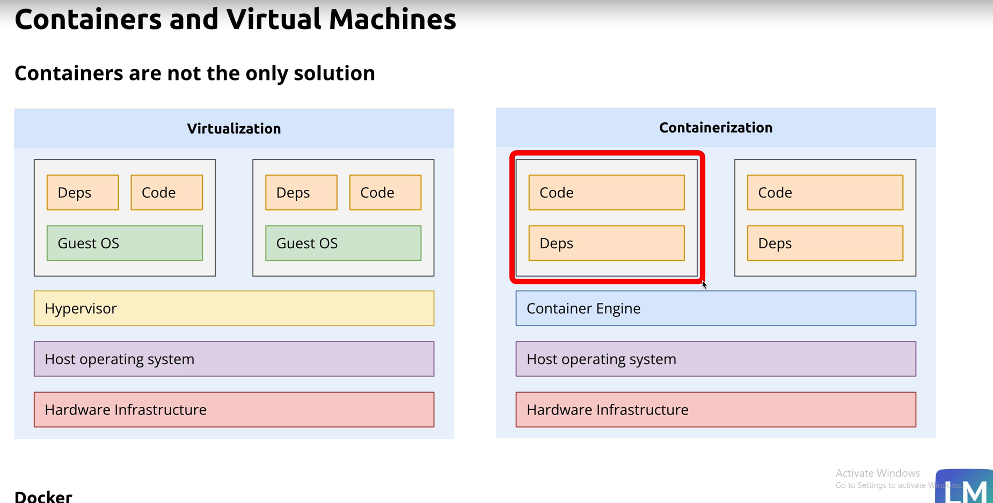
In Computer Science, a kernel is the core part of an operating system. It acts as a bridge between:
- Hardware (CPU, RAM, devices)
- Software/applications (programs users run)
The kernel controls and manages the system’s resources.

Main functions of a kernel
- Process management
  - Runs and schedules programs
  - Handles multitasking
- Memory management
  - Allocates and frees RAM
  - Prevents programs from interfering with each other
- Device management
  - Communicates with hardware like keyboard, disk, printer
- File system management
  - Reads/writes files on storage devices
- Security & access control
  - Restricts unauthorized access to resources

Types of kernels
- Monolithic kernel
Most services run inside the kernel
Example: Linux
- Microkernel
Only essential functions stay in kernel mode; other services run separately
- Hybrid kernel
Combination of both approaches
Example: Windows NT

Simple analogy
Think of the kernel as the manager of a computer:
- Applications make requests
- The kernel decides how hardware resources are used
Without a kernel, software cannot properly communicate with hardware.
show me the diagram
Here’s a simple diagram of how the kernel fits inside a computer system:
+----------------------------------+
| User Applications |
| (Browser, Games, MS Word, etc.)|
+----------------------------------+
|
v
+----------------------------------+
| Kernel |
|----------------------------------|
| Process Management |
| Memory Management |
| Device Drivers |
| File System Management |
| Security & Scheduling |
+----------------------------------+
|
v
+----------------------------------+
| Hardware |
| CPU | RAM | Disk | Keyboard |
| Monitor | Printer | Network |
+----------------------------------+

Flow
- Applications request services
- Kernel processes the requests
- Kernel communicates with hardware
- Hardware sends results back through the kernel
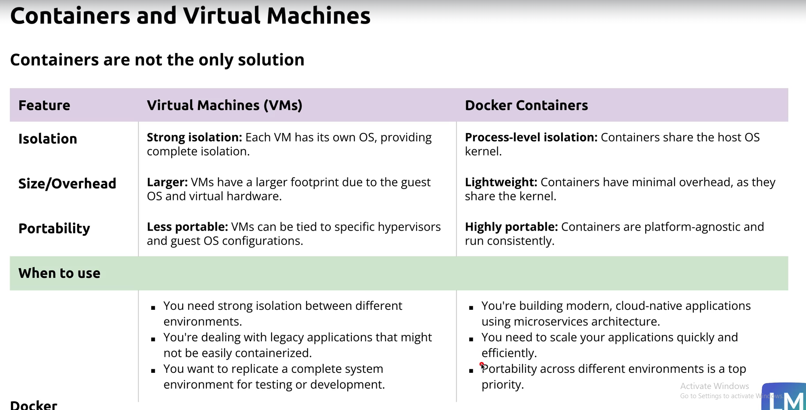
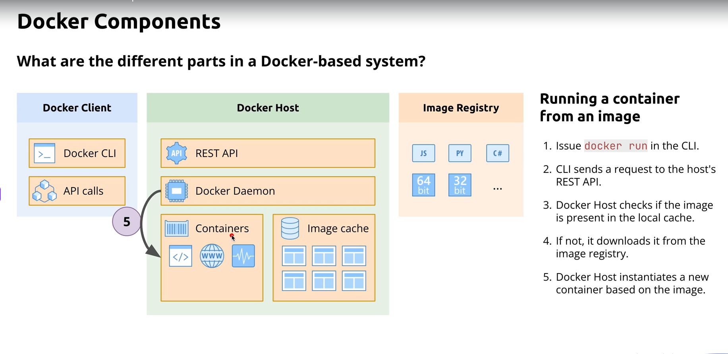
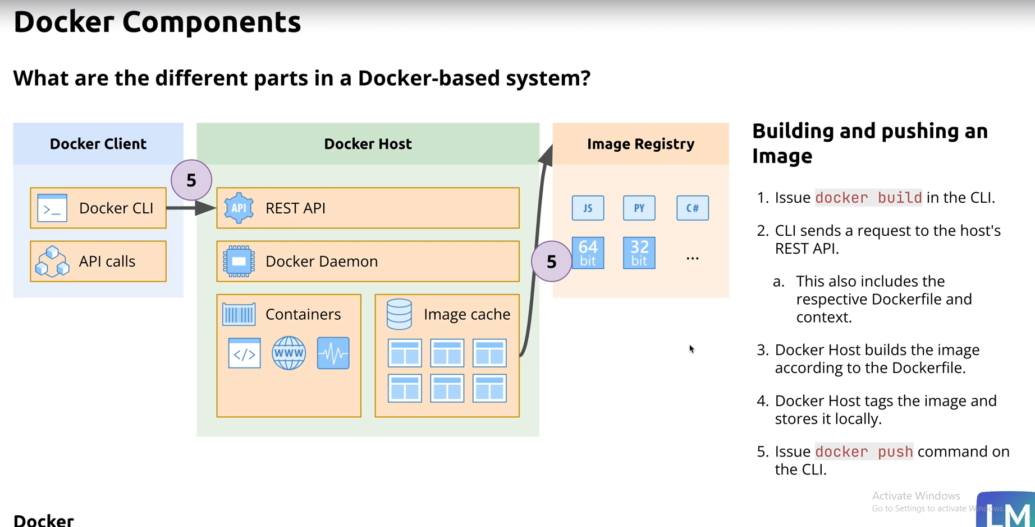
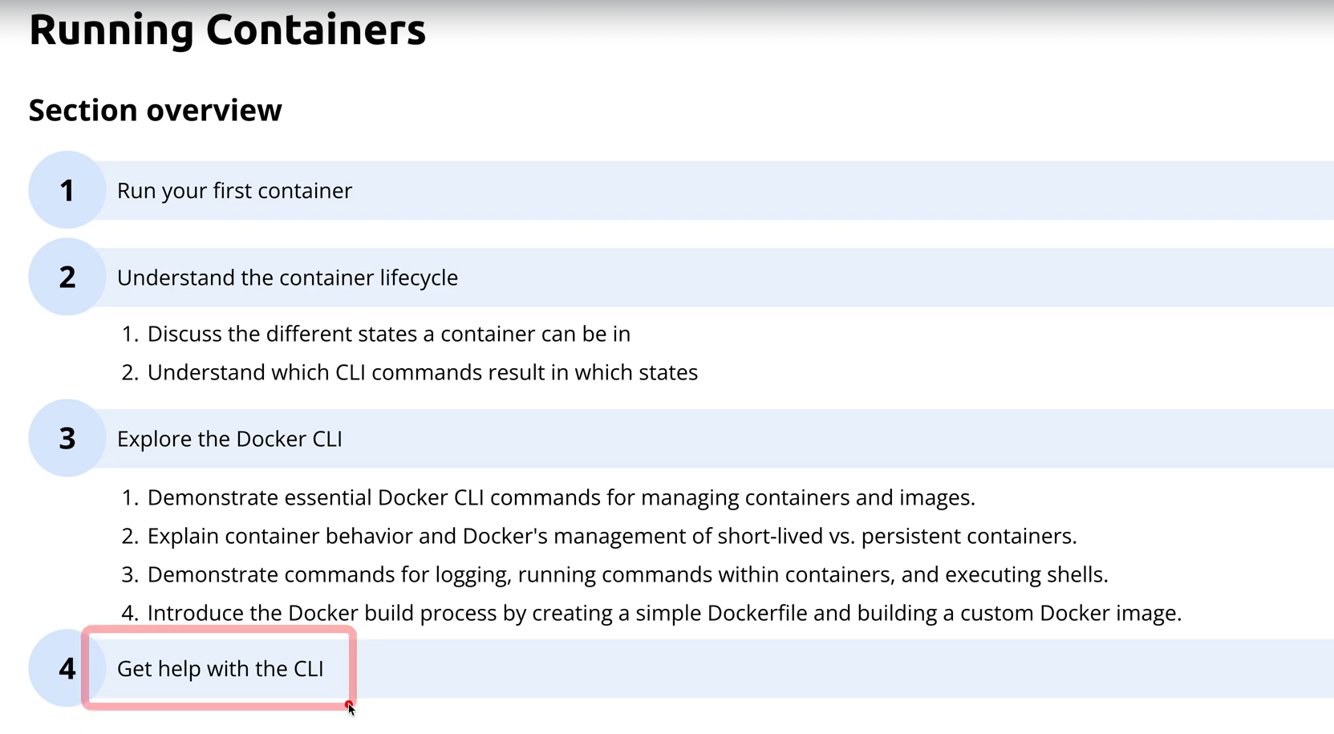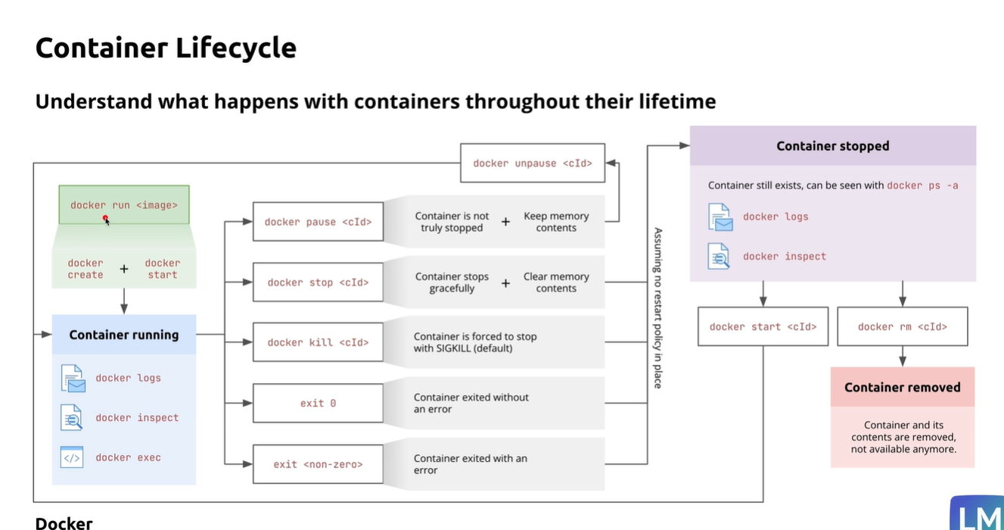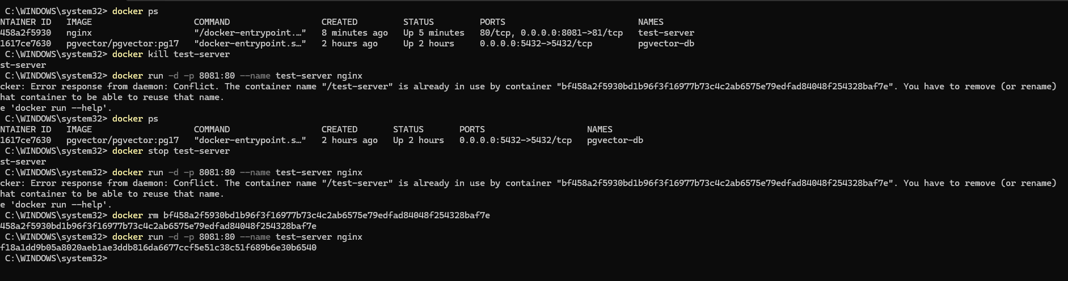
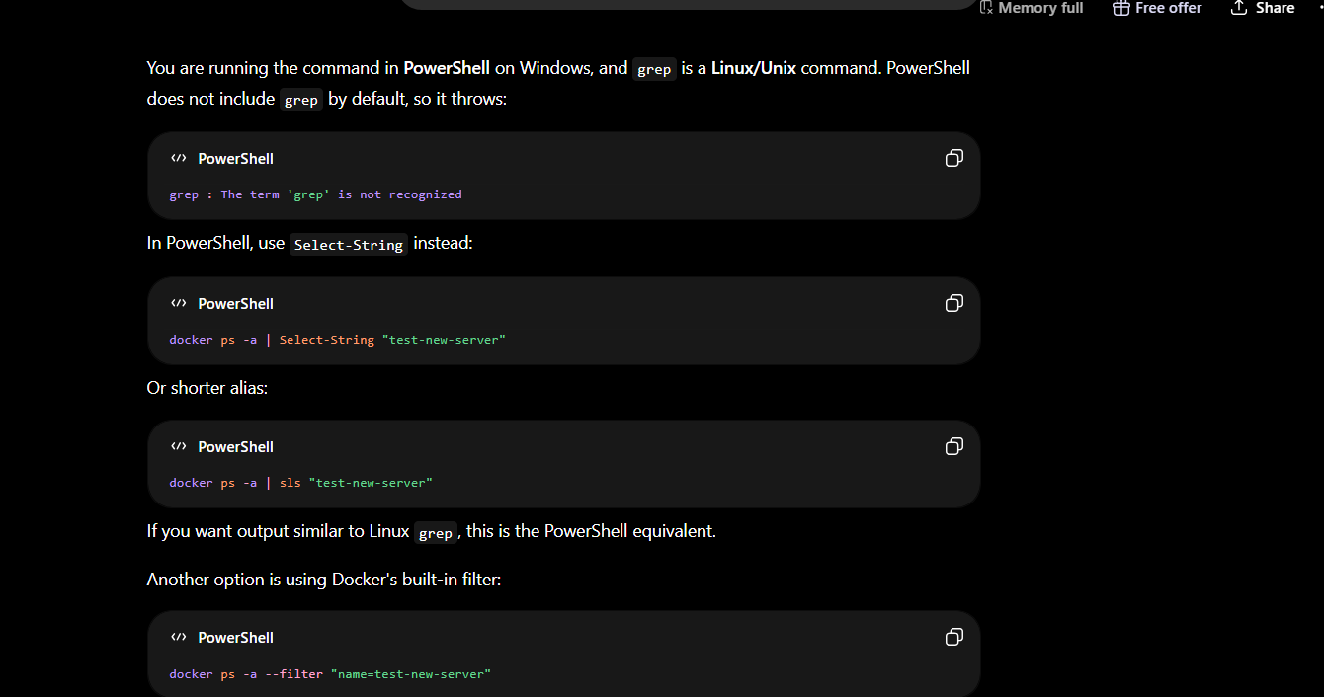
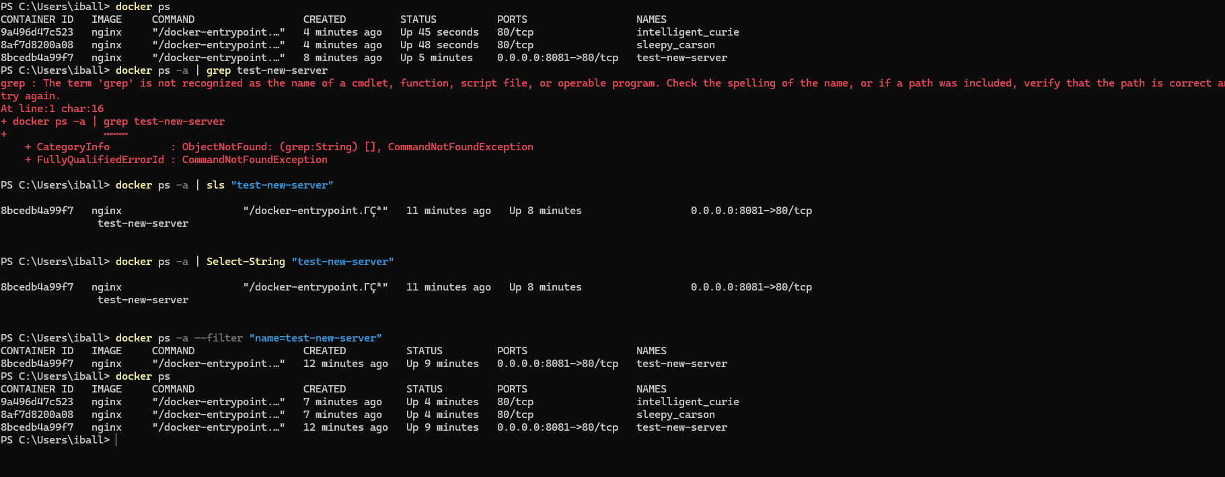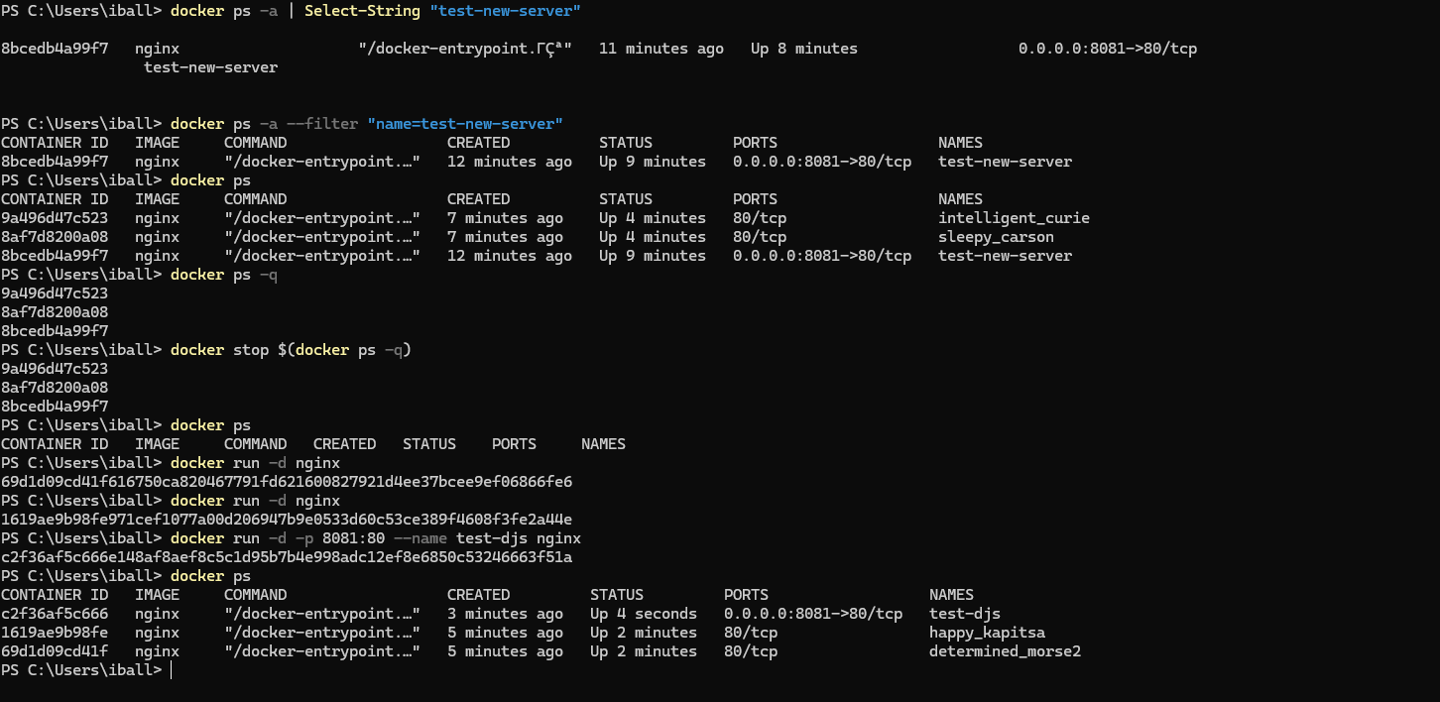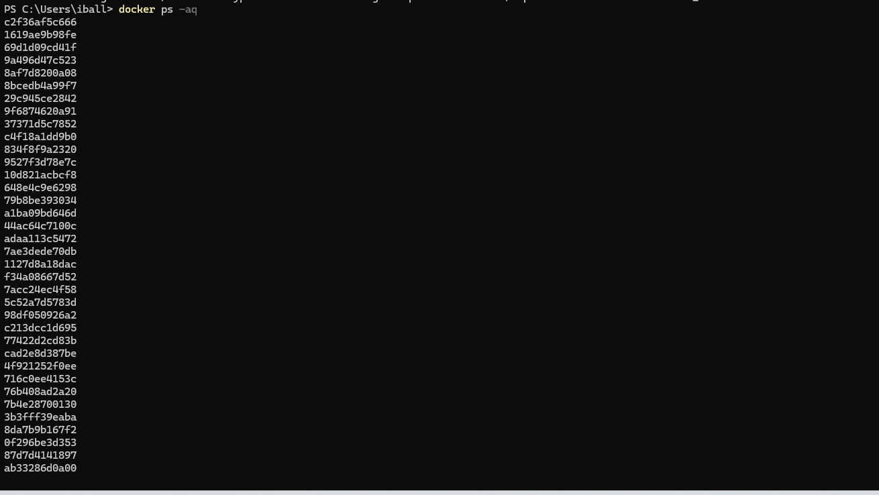
aq – returns all numeric ids of running and stopped containers
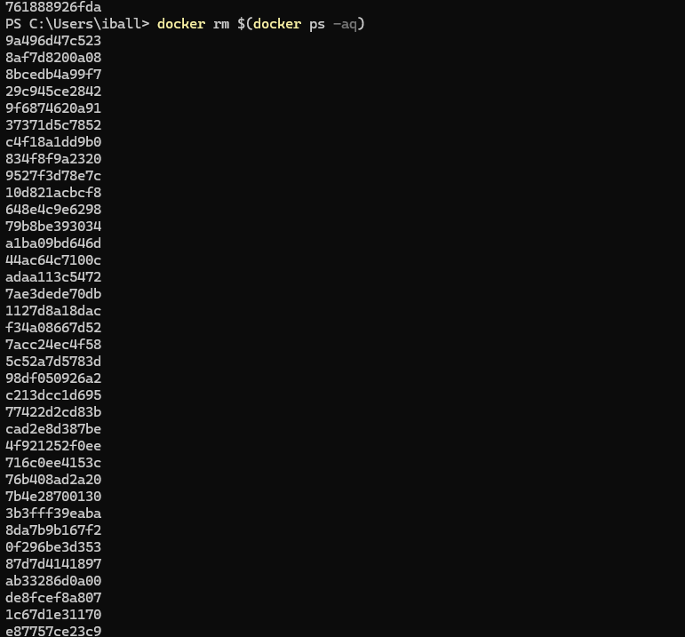

Working with nginx:- NGINX (pronounced "engine x") is a high-performance, open-source web server software originally created by Igor Sysoev and released in 2004. It is widely used for HTTP serving, reverse proxying, load balancing, caching, and media streaming.
- Architecture: Unlike traditional servers that create a new thread per connection, NGINX uses an event-driven, asynchronous model to handle thousands of concurrent connections with minimal resource usage.
- Primary Uses: It serves static content efficiently, acts as a reverse proxy to hide backend infrastructure, distributes traffic across multiple servers (load balancing), and caches responses to improve speed.
- Market Position: As of 2025, NGINX is the most popular web server, powering over 33% of all websites, ahead of Apache and Cloudflare.
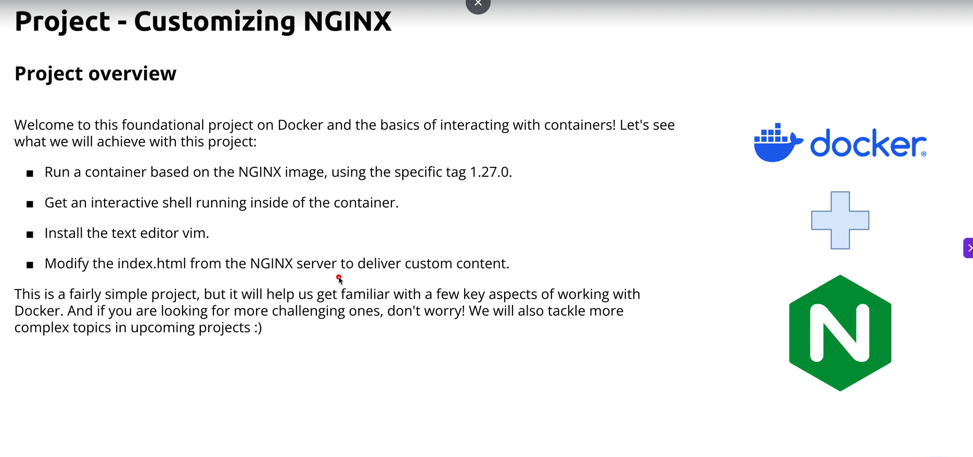
Vim (short for Vi IMproved) is a highly configurable, keyboard-driven, modal text editor included by default in most Linux distributions.
It is an enhanced version of the original Unix Vi editor, designed for speed, efficiency, and extensive customization without relying on a mouse or graphical interface.

Core Functionality: Vim uses modal editing, primarily switching between Normal Mode (for navigation and command execution) and Insert Mode (for typing text).

Primary Use Cases: It is widely used by developers and system administrators to edit source code, configuration files, and scripts directly within the terminal.

Key Features: It supports syntax highlighting, multi-level undo, plugins, and complex text manipulation commands that allow users to stay on the keyboard's home row.

Availability: As it is pre-installed on most systems, it serves as a reliable fallback editor for system repair and minimal environments.
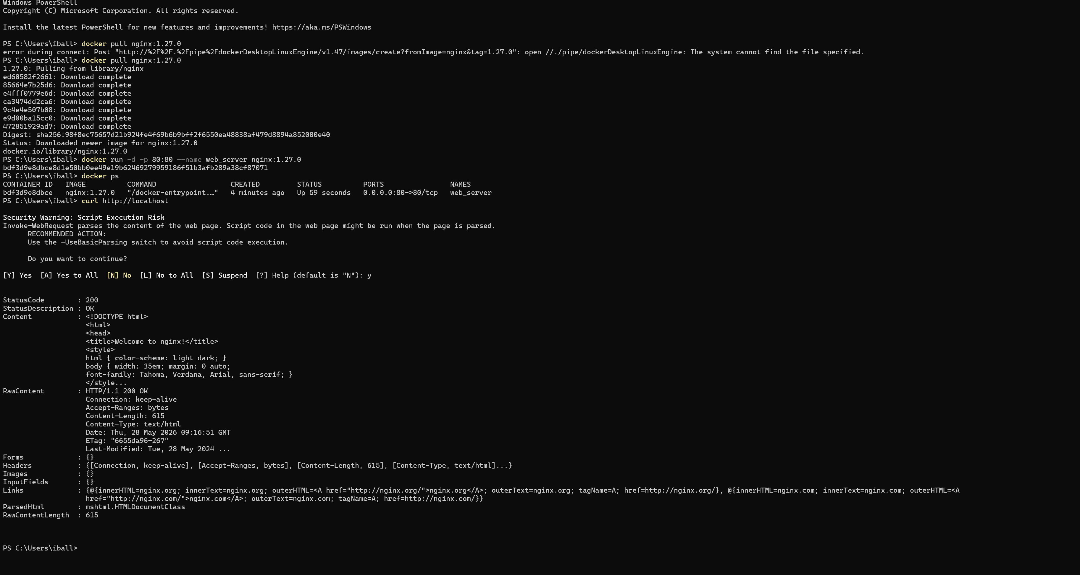
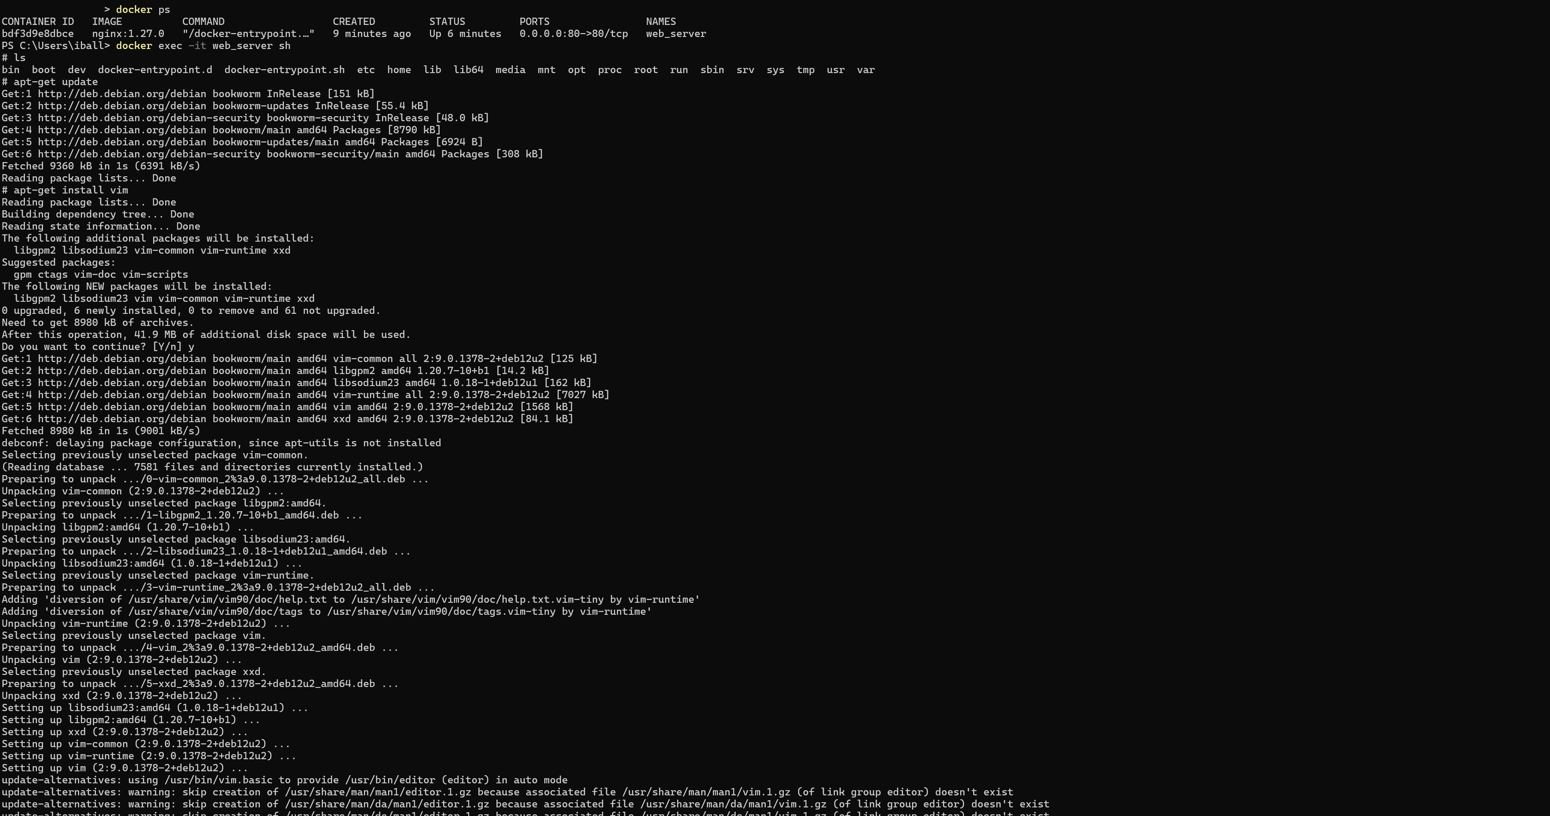
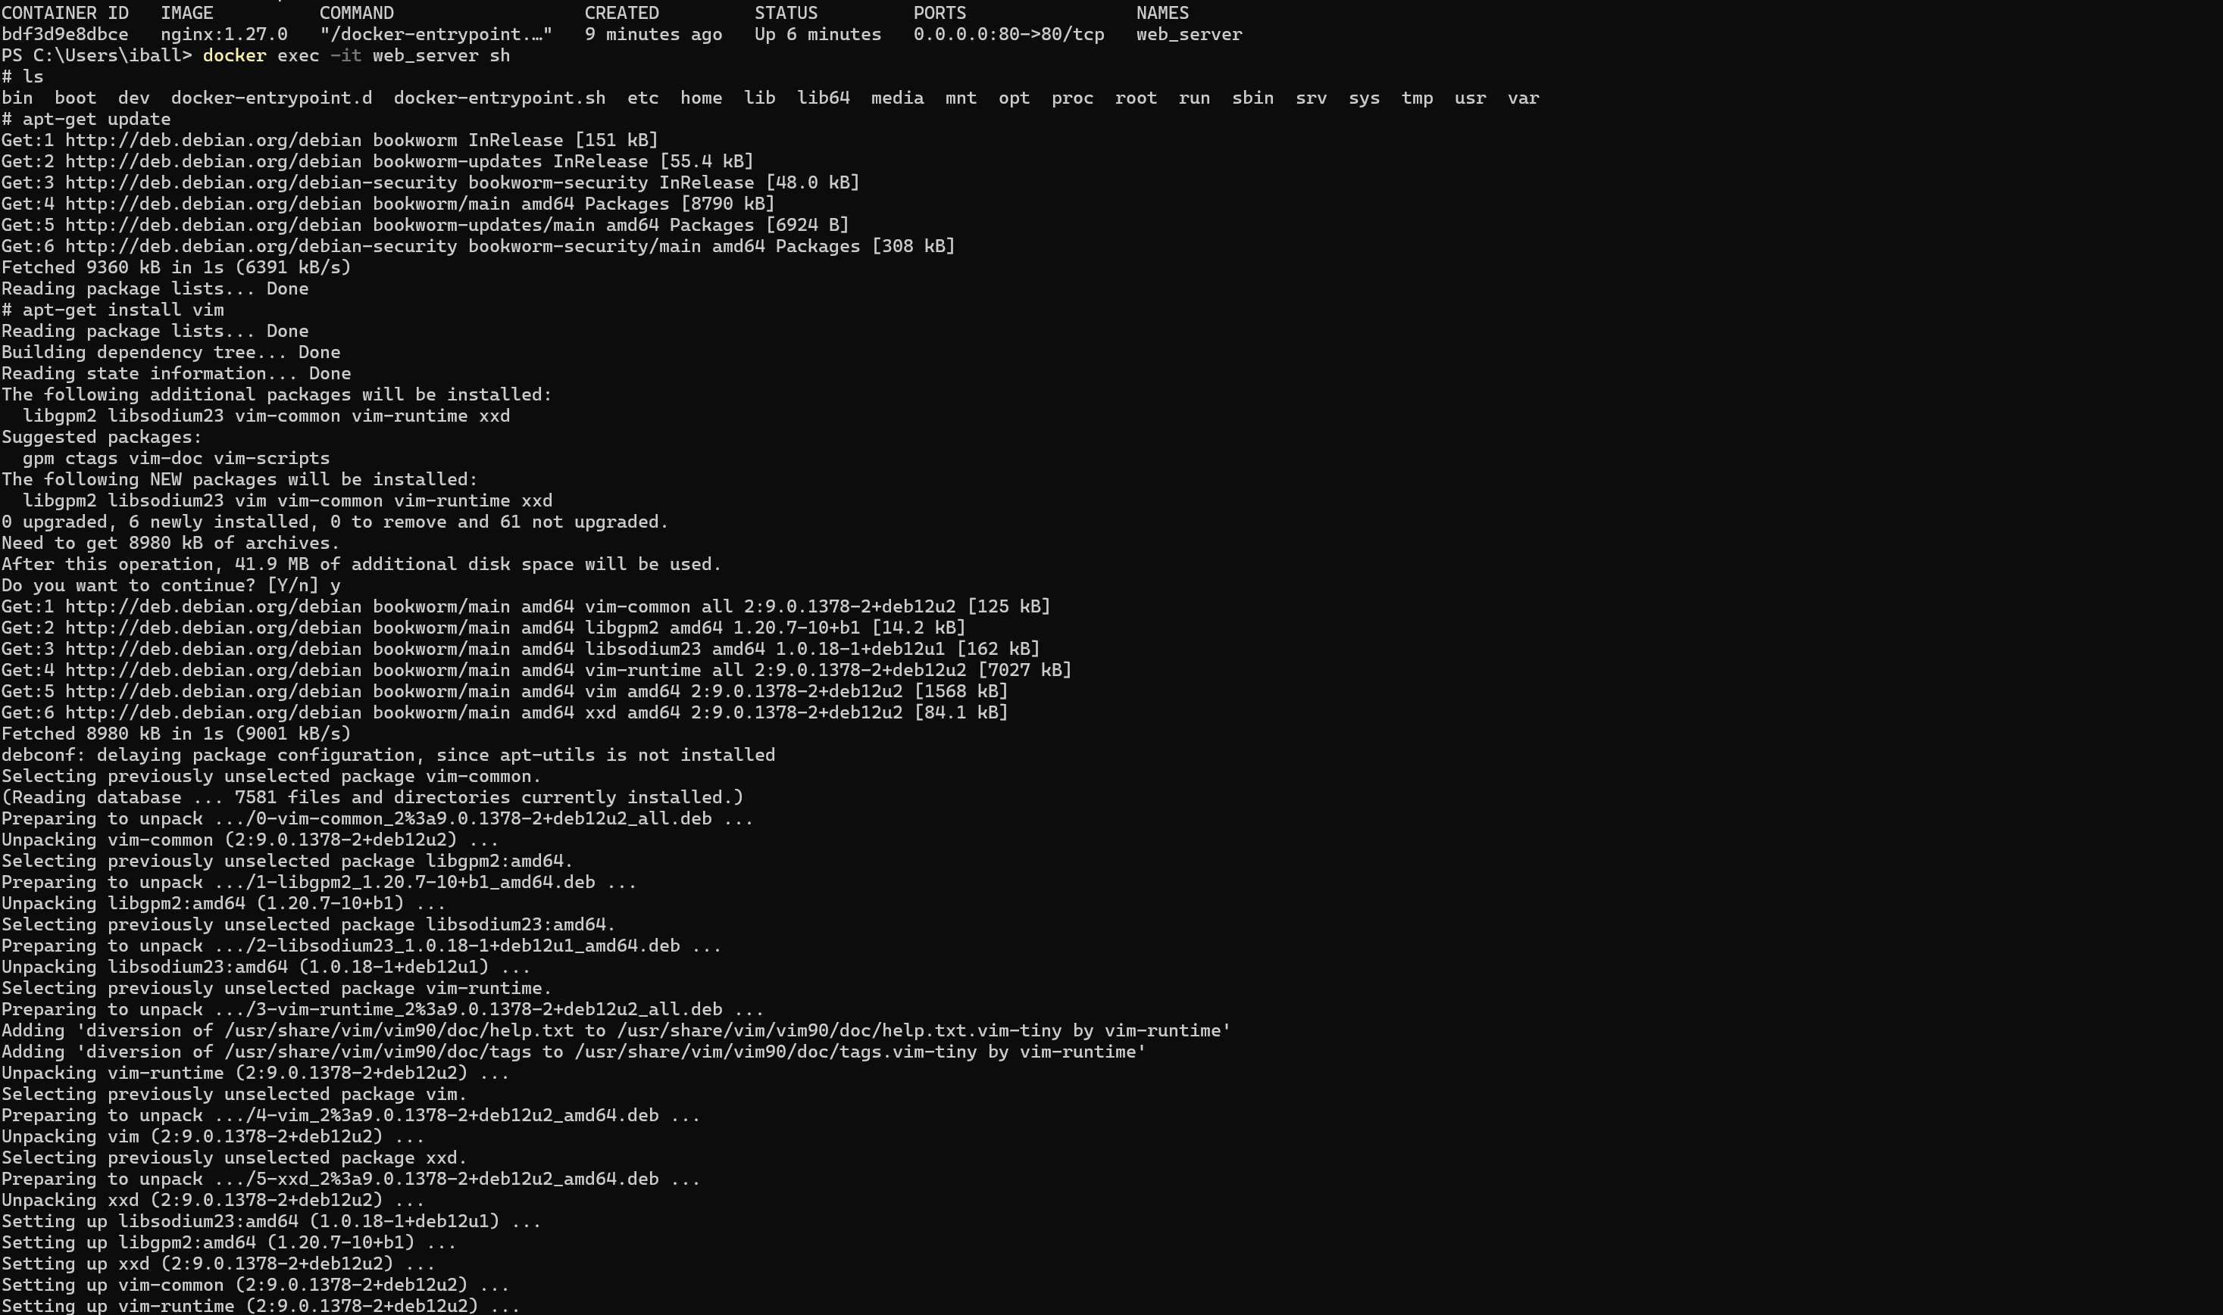
The cat command is not a built-in feature of the Vim text editor; it is a standard Linux/Unix command-line utility used to concatenate files and display their contents. Vim and cat serve different primary functions: cat is a command-line tool for viewing and merging text, while Vim is an interactive visual editor for creating and modifying files.

Press – esc + :wq then press enter it will write and resolves the file.

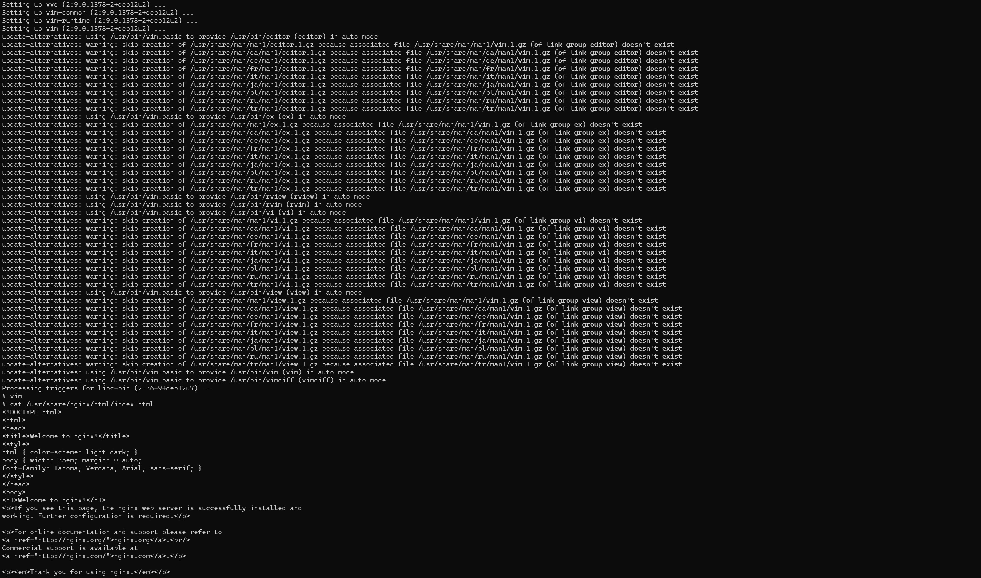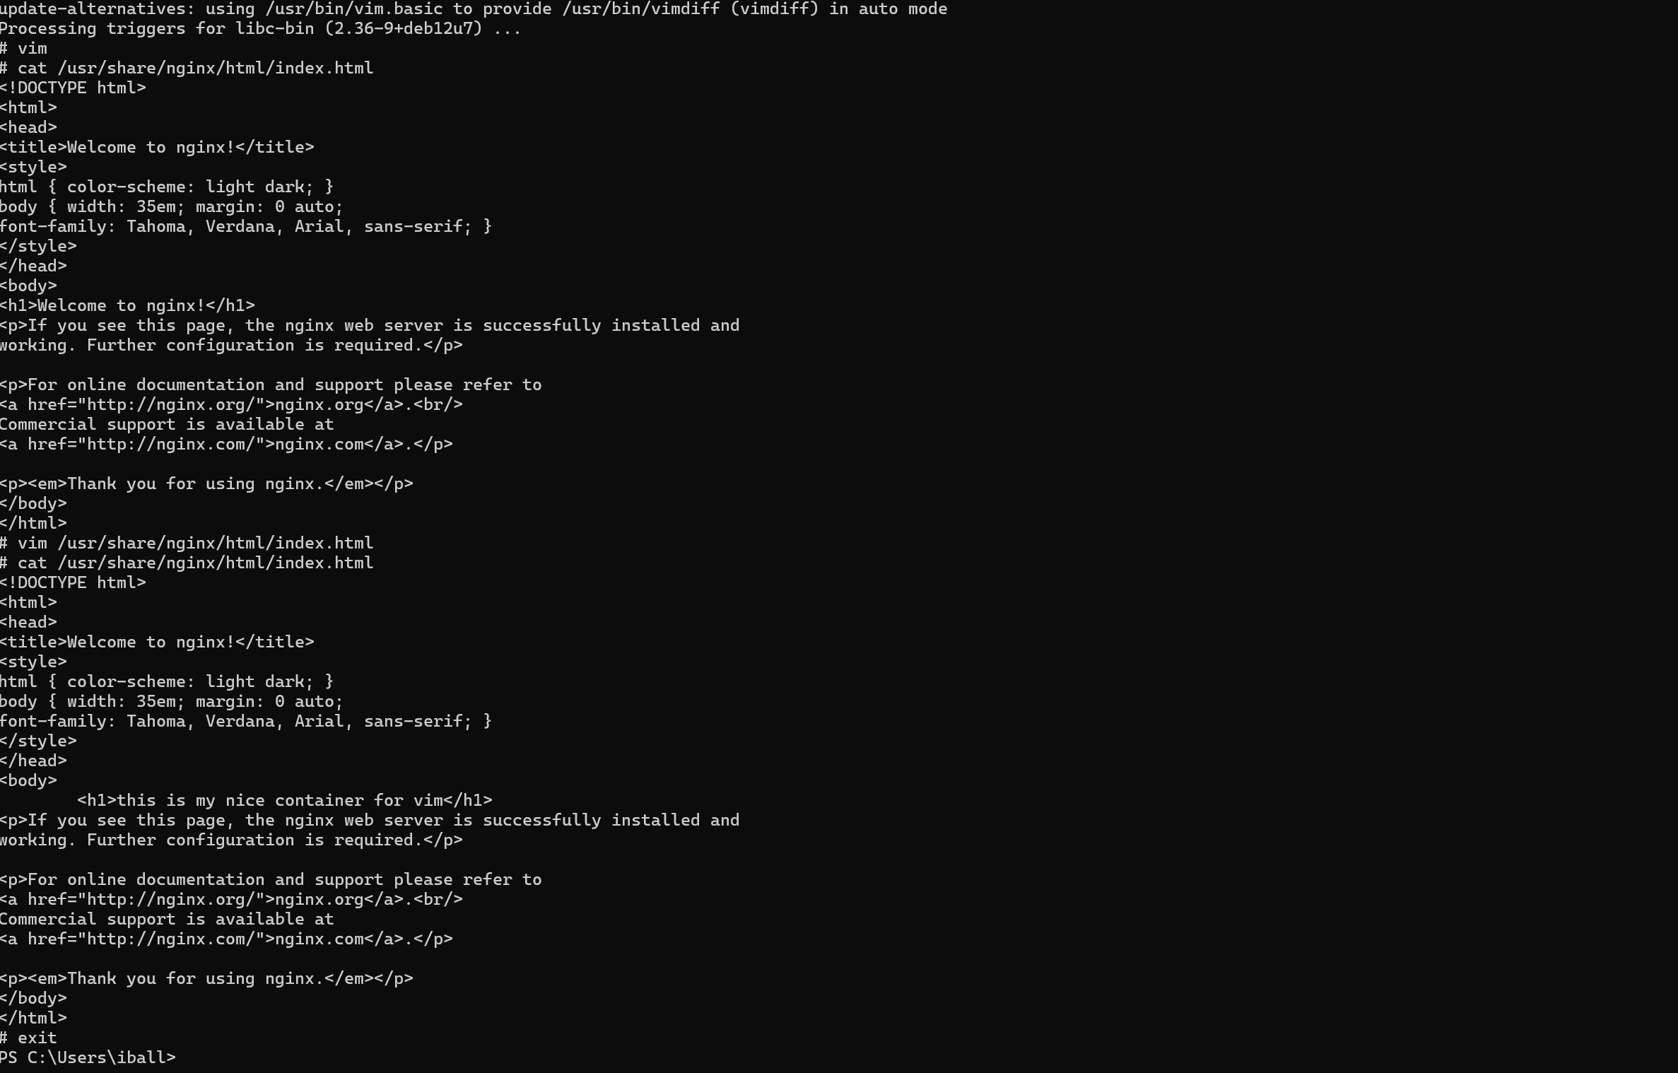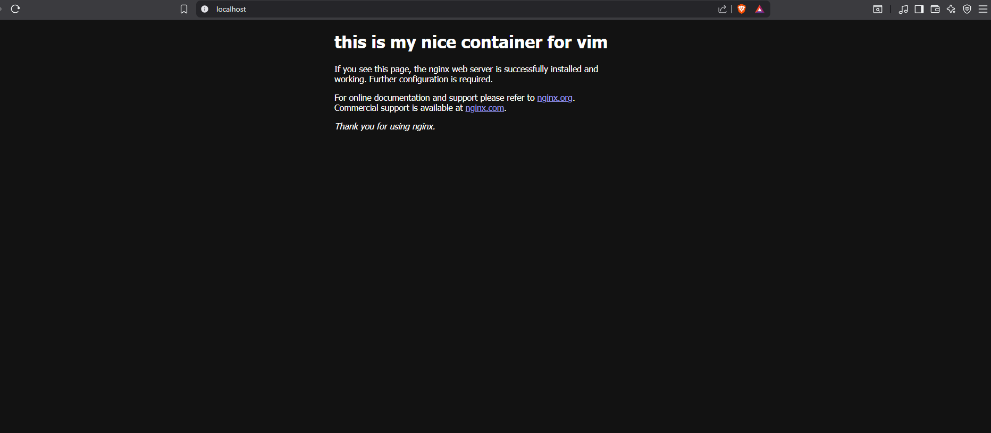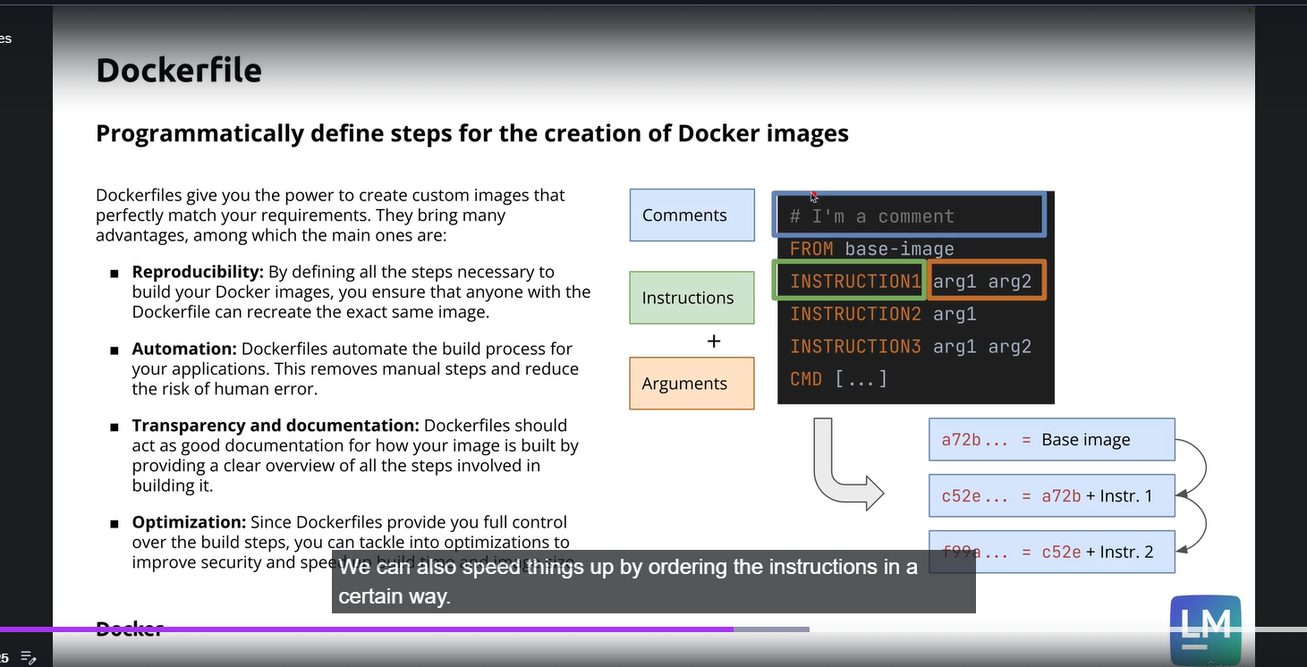

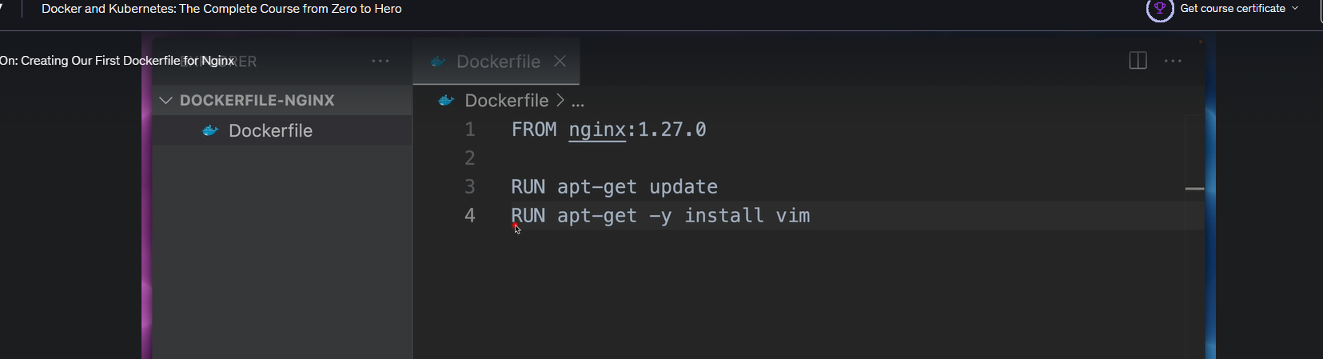

( 30-June-2026 )

In this I have run the dockerfile and goes inside the container.

